|  |
| --- |
| **TurnQuest Everest Insurance Suite**  **General Insurance System(GIS)**  **Claims User Manual** |

June 2014

**Table of Contents**

**SALVAGE BUYER DEFINITION**

**CREATE CLAIMANT**

Claimants Definition

**CLAIMS PROCESSING**

Claims Opening

Policy Enquiry

**LETTERS AND MEMOS**

Claim Transaction Report

Claim Booking Details Tab

*Other Claim Details Section*

*Required documents*

*Court Details (Legal Module)*

**CLAIMS REVISION**

**CLAIM FEE PAYMENT.**

Appointing of service Providers

Claim Fee Payment Process

**CLAIMS PAYMENT**

Claimant Details Tab

Discharge Voucher (DV)

Claim Payment Process

**CLAIMS SALVAGES**

Salvage retained by Claimant

Salvage retained by Insurance Company

Salvage Tagging Tab

*FMS salvage receipting*

**CLAIM EXCESS.**

FMS Excess receipting

**CLAIMS CLOSING**

**CLAIMS REOPENING**

**CLAIMS CONTRA**

**CLAIM ENQUIRY**

**CLAIMS EDITING**

Claims Transactions

**CLAIMS LOADING**

**CLAIM AUTHORIZATION LEVELS**

# **Salvage Buyer Definition**

Claims module>> [Salvage Buyers Definition](http://10.176.18.13:7004/GISHERITAGE1/faces/defineBussPerson.jspx?_adf.ctrl-state=i4fnslpuc_29)

[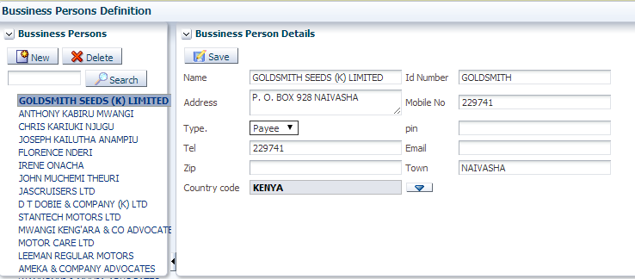](http://10.176.18.13:7004/GISHERITAGE1/faces/defineBussPerson.jspx?_adf.ctrl-state=i4fnslpuc_29)

This screen is used to capture the details of the Salvage buyers. To create a new salvage buyer, click on new button and enter the details by the Labels indicated above.

# **Create Claimant**

## ***Claimants Definition***

The screen below is used to capture third party claimant’s details.

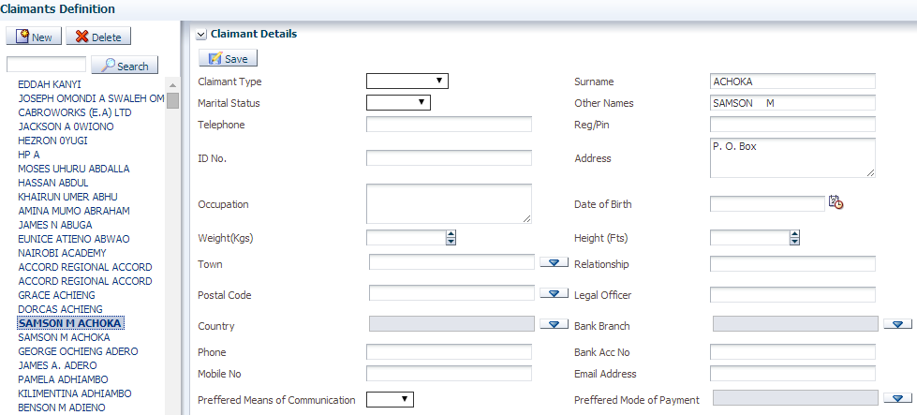

Click on New **Claimants Definition** to define a new claimant from the **claims setup menu** item of the **claims module**

The screen below appears

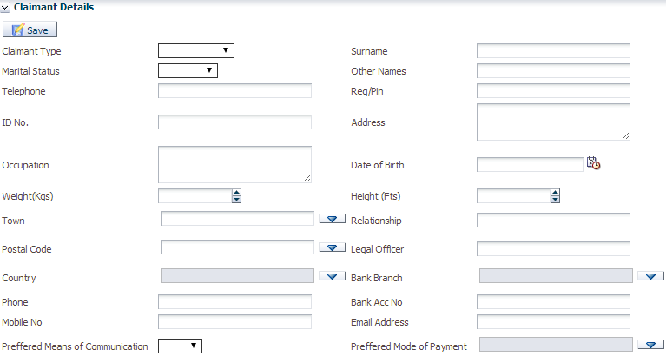

Capture the claimant’s details as indicated by the Labels and click on save.

# **Claims Processing**

## ***Claims Opening***

**Claims module>>Claims Opening**

Below is the claim opening screen.

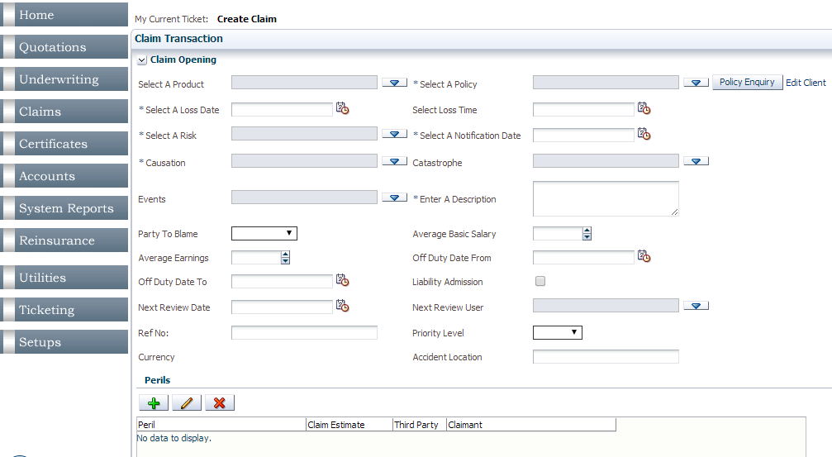

*Filed marked as * are Mandatory*

*Current ticket should Read:* ***Create Claim***

Search for the policy from the “Select a Policy “from the drop down drop List as shown on below screen.

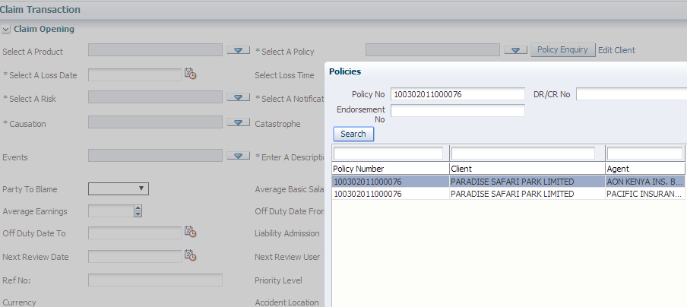

Enter the Loss Date (Specific date when claim occurred) and the Notification Date (date when the claim was reported).Select risk ,the risk that you want to start a claim on. (All the risks that fall within the Loss date and the policy cover dates are listed for the specific policy). This is as shown on below screen.

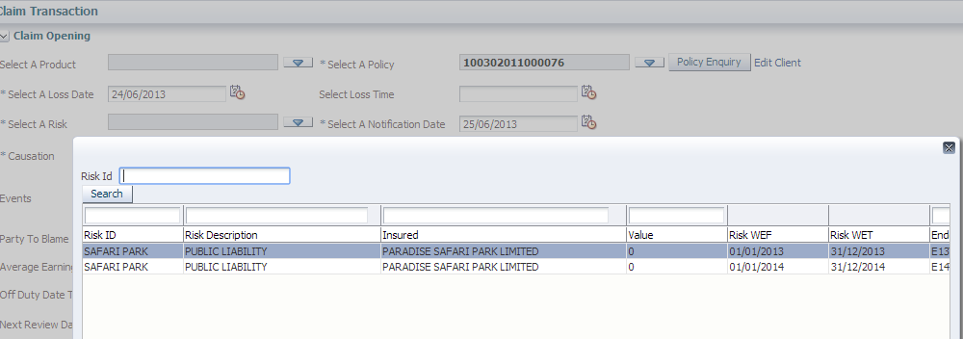

Note: If the risk selected has a claim that is already opened on it, a dialogue box is displayed with details of the current claim on that particular risk as displayed above, you can edit the Claim or click cancel to Continue capturing a new claim. The screen is as shown below.

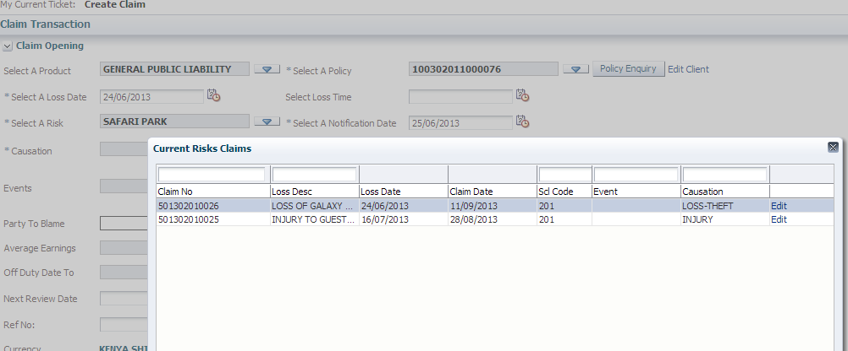

Select Causation (what actually caused the claim), Catastrophe or Event (for the purpose of linking several claims to the same event) if the information is available. See below screen.

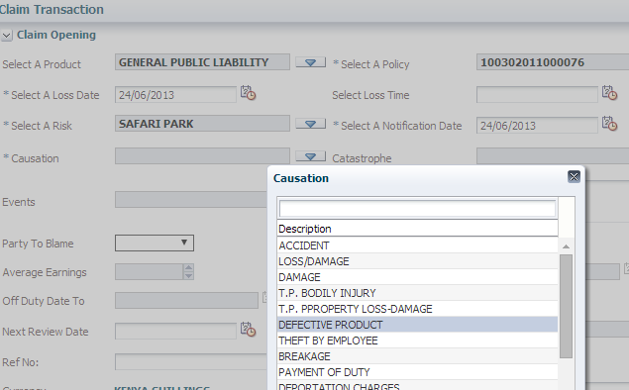

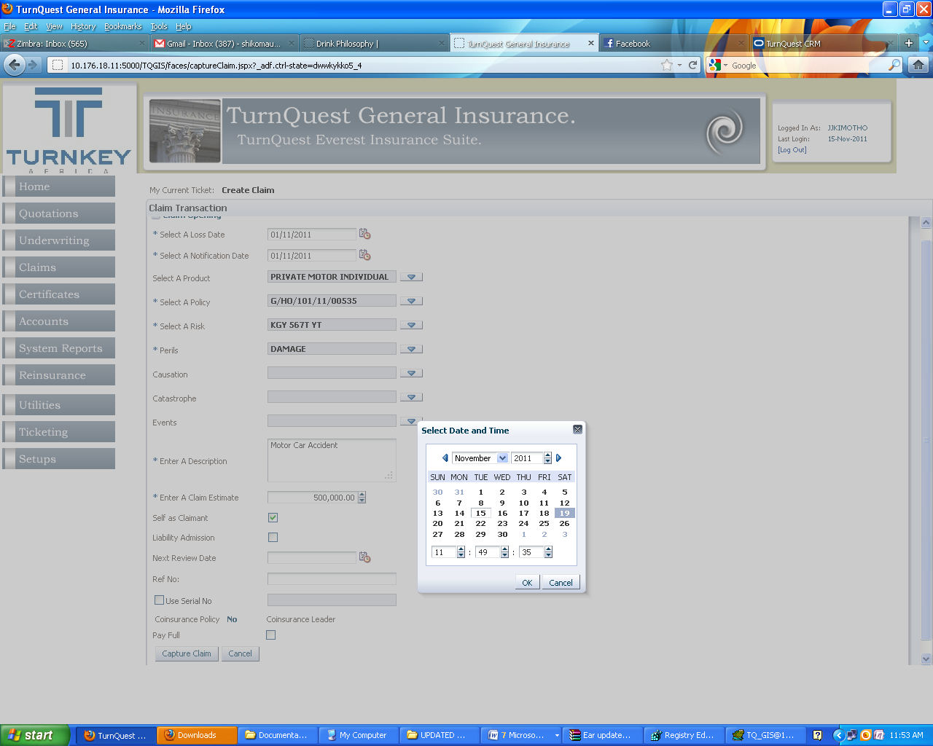

Fill in the other fields as explained below;

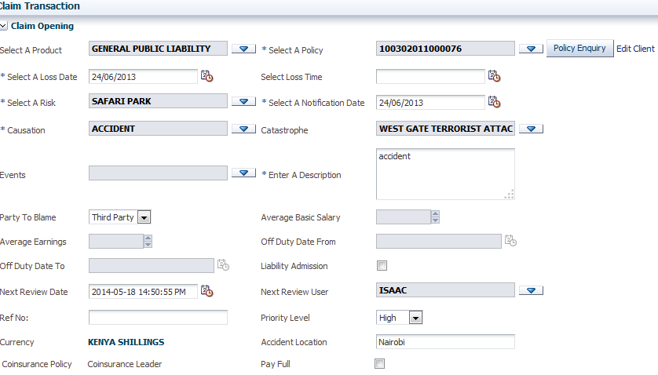

Enter a Description: This field is used to enter the loss description.

Party to Blame: select if the party to blame is Third Party, insured or none.

Average Basic salary, Average earnings, off Duty Date From Fields are used where the product is GPA or PA.

Liability Admission: Claimant accepted liability which might result into the claimant being penalized.

Reference No: Enter Reference number of the claim; this is the claim number that was generated by a broker.

Next Review Date: The date selected here will automatically create a calendar (diary) item for the review date and a notification email will be automatically sent to the user (Next review user) on that particular date and time as shown above.

Coinsurance policy: show if the policy is a coinsurance or not, Select if the payment is

Full, where you are leading combined meaning that you pay on behalf of the other coinsurers and send debit notes to them for recovery.

Select Perils (These are perils that are attached at underwriting and the system checks such that if they were not entered at UW, Setup perils default are listed on the LOV. This is done on below screen.

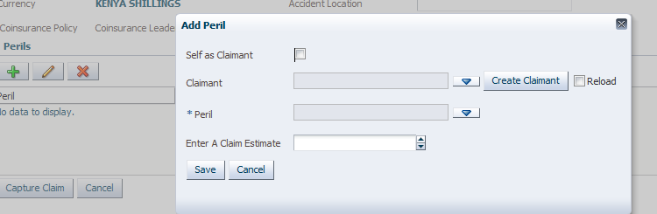

If self as claimant checkbox is ticked, it means that the claimant is the client attached to the policy, thus the claimant field is disabled. If this field is not selected then it means the claimant is third party.

Click on create Claimant Button to add details as shown below. Capture the details and click on save

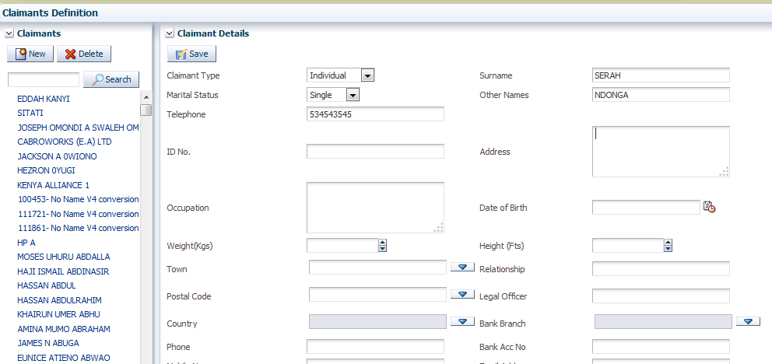

Capture the available claimant details and click on save. Select the Reload check box to as shown on below screen. The new claimant name is picked as shown on the below screen.

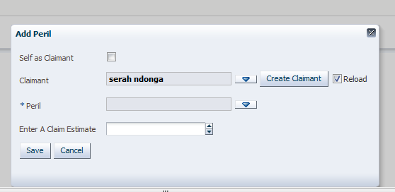

Select the peril as from the LOV as shown below.

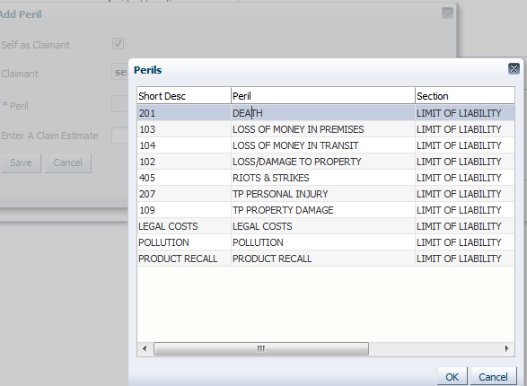

Enter the claim estimate amount, this is the Underwriters claims estimate amount and click on save.

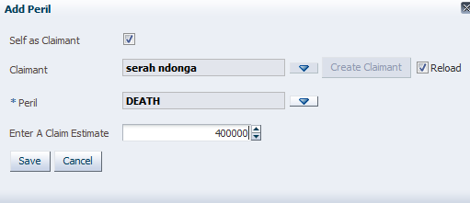

**Click Capture Claim**

Click on capture claim Button as shown below.

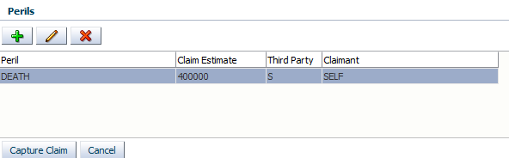

The claim transaction screen appears as shown below.

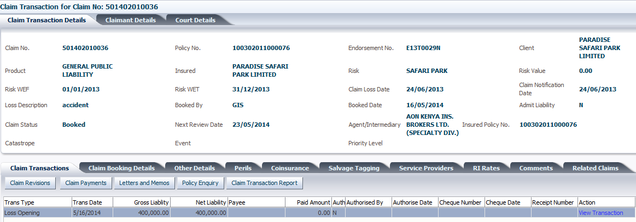

*Current Ticket:* ***Loss Opening Data Entry***

**Note:** Claims Transaction Screen also Known as the Claims Landing Screen where all transactions can be accessed (Claims Revisions, Payments, letters and memos, Policy enquiry and claims transaction report)

The bottom section of the screen shows the claim movement based on the transactions done on that particular claim

The client policy and insured property details are automatically picked by the system.

## ***Policy Enquiry***

Click on **Policy Enquiry** to access the policy details as shown below.

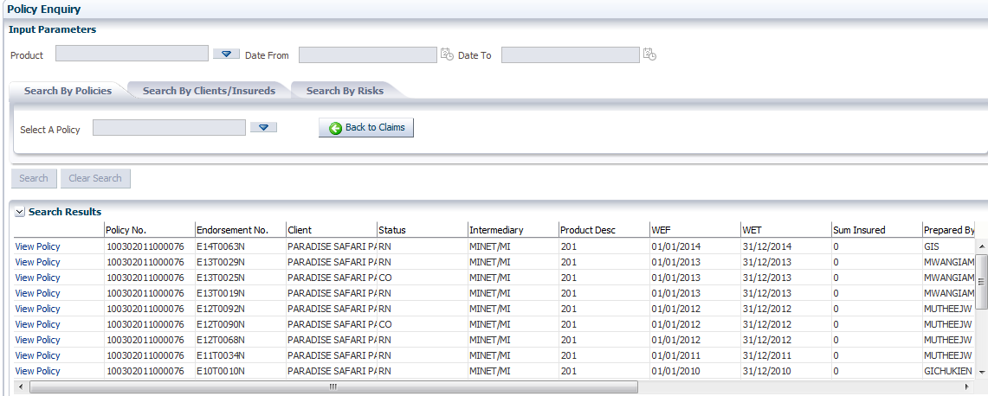

The policy will be on enquiry Mode and no changes are allowed on the only viewing and printing of the transactional reports is allowed. To go back to the claim Click **Back to enquiry** on the policy Details screen as shown above

Click on the back button to resume claim.

# **Letters and Memos**

At this point, an acknowledgement letter is done to the claimant acknowledging receipt of the claim notification and also asking for the claim substantiating documents. This letters are done using the Letters and memo screen , accessed by clicking the Letters and Memos button On the claims transactions Tab.

This will redirect you to the screen below for Processing letters and memos which are send to the claimant or agent copying the claimant, agent, coinsurers and any other interested party as need be.

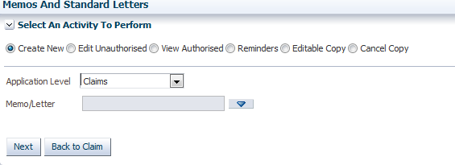

Click next to create a new letter

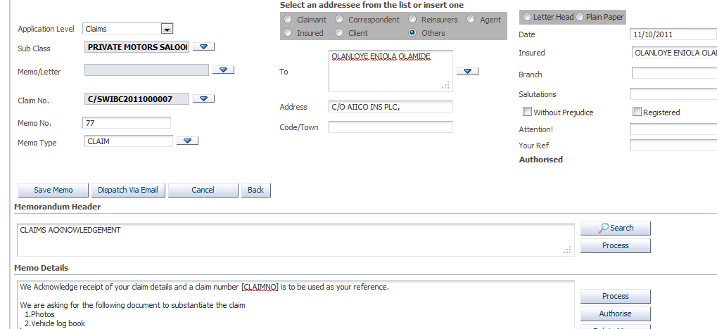

Letters and Memo templates are setup in the messaging menu in the TurnQuest CRM system.

The fields enclosed in square brackets [] are merge fields which will append the details from the transaction for example Claim No. , Policy number, insured, address etc

After these, you can appoint an Engineer for Motor, Supretendants for marine and Loss adjustor for the others to validate the claim and substantiate the validity of the claim using the claim submitted docs and site visit

The Engineer determines if the claim is total loss or partial loss (repairable loss)

Once that is verified, you go to the claim and tag it as either partial or total loss .Partial loss means there is no salvage while total loss means there might be salvage in the claim.

In cases of total loss, you also need to tag if the claimant is retaining the salvage or not meaning that if he retains the salvage you pay him less the salvage value else you open the salvage to bidding process. ***(Covered in the salvage processing section)***

Click Back to return to the claim transaction.

## ***Claim Transaction Report***

Claim Transaction Report Tab I used to display below report that shows a summary of the captured claim.

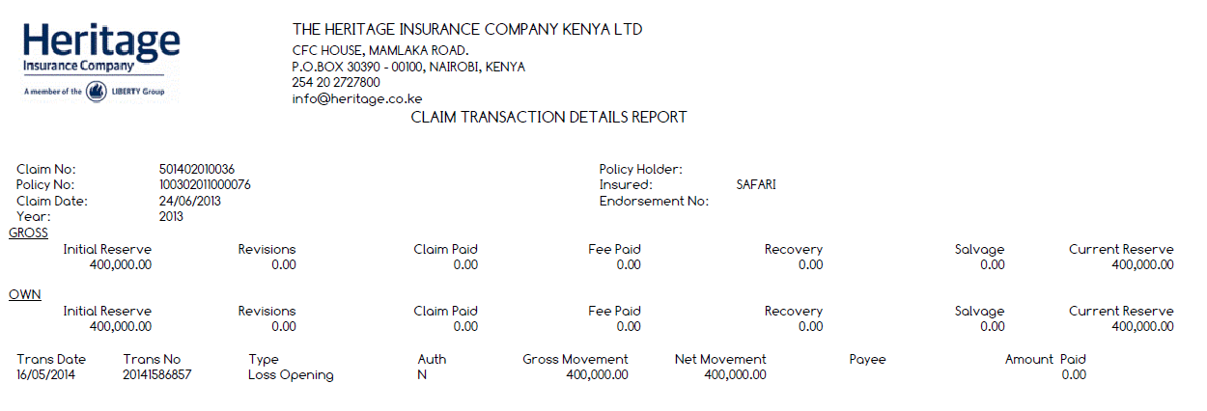

## ***Claim Booking Details Tab***

This is where you capture all the Claim Details as show below

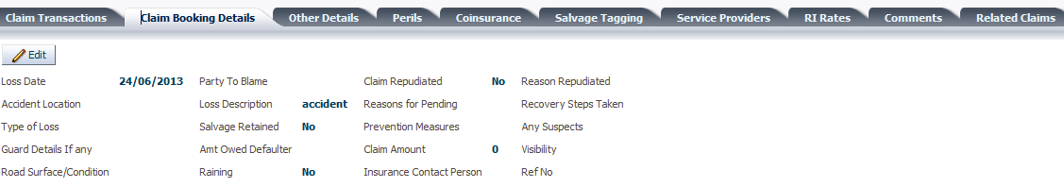

Click on Edit to change/add claims details

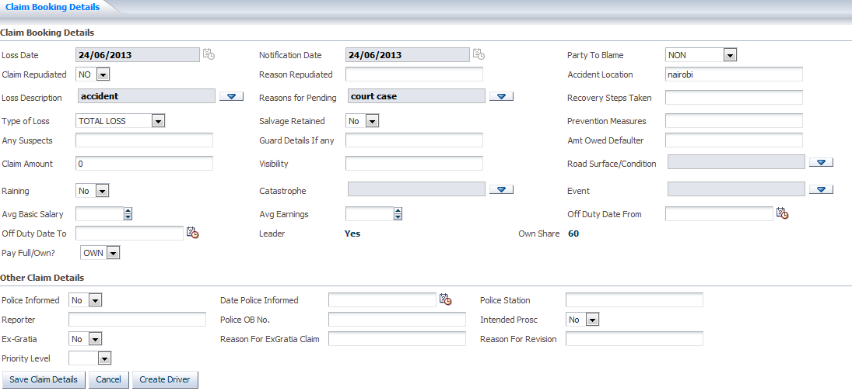

Select if the claim is repudiated yes or No. If yes enter the reason repudiated.

Select party to blame (None, Insured or Third party).

Enter accident Location.

Select the Type of loss (Total Loss or Repairable loss) it’s used in the computation of reserve,

### ***Other Claim Details Section***

This section is for entering the Police details that is if available for a particular claim as shown below.

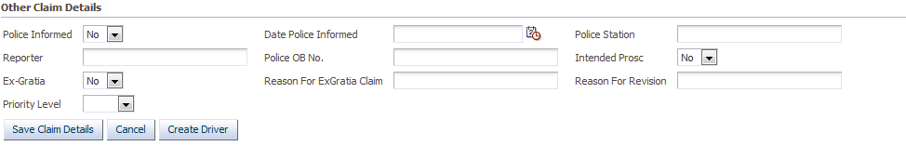

Also on this section one can capture the driver details by clicking Create Driver Tab as shown above. This opens below screen. Click on new to create a new Driver enter details and save. Click back button to claim to continue.

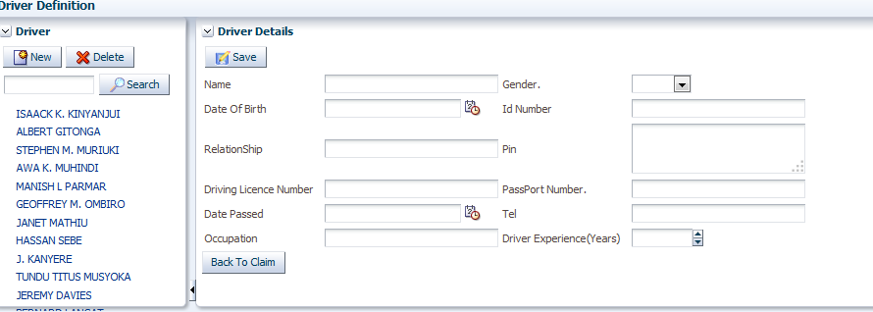

### ***Required documents***

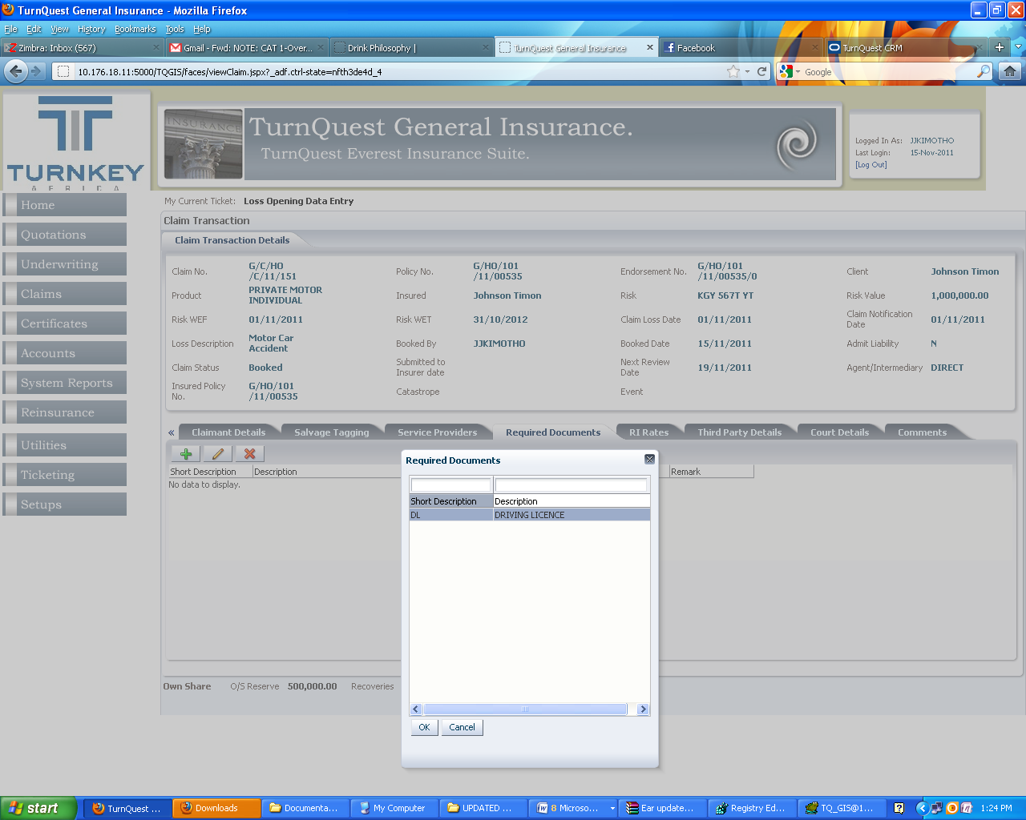

This are required documents as per set up: **see setup documentation**

**\**Recall Documents that have been set up as mandatory have to be selected,***

Select whether document has been submitted, enter the submitted date and Reference No.

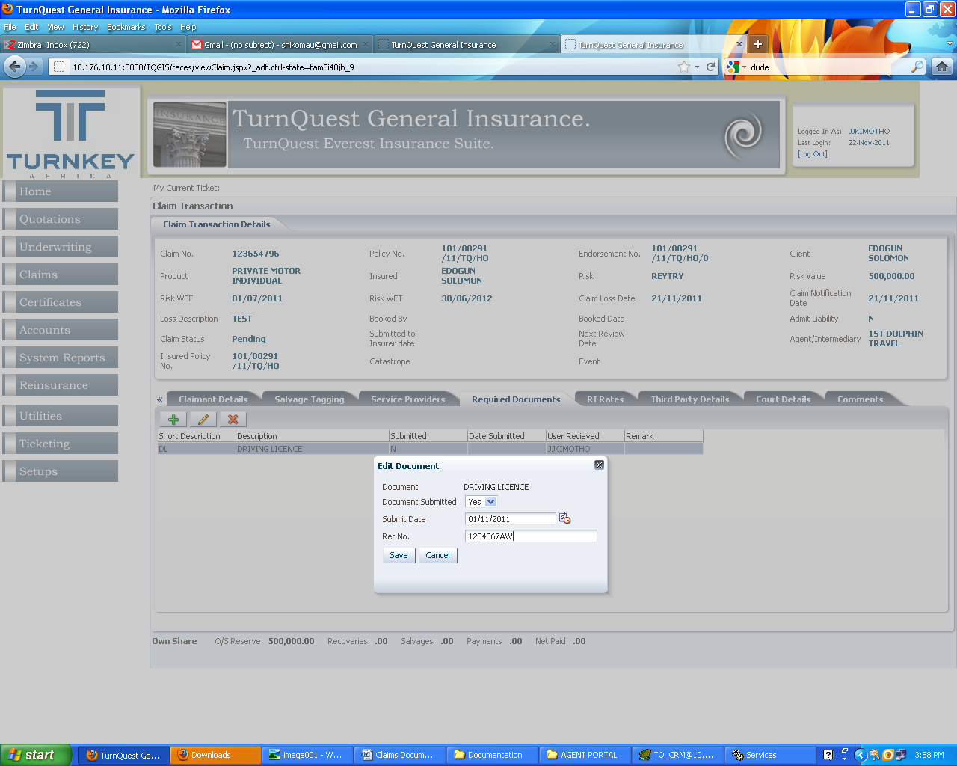

The system automatically picks the User Received as the current user attaching the required documents

### ***Court Details (Legal Module)***

This section is for registering or updating the legal details

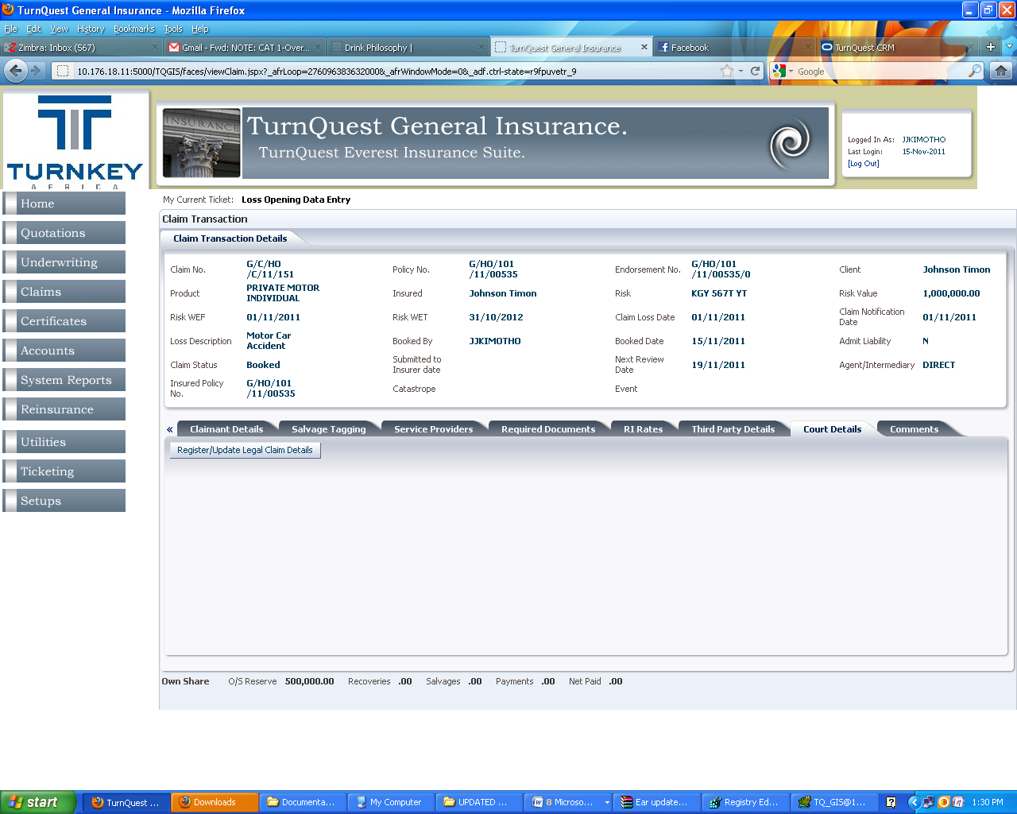

Click Register / Update Legal Claim Details to access the screen below

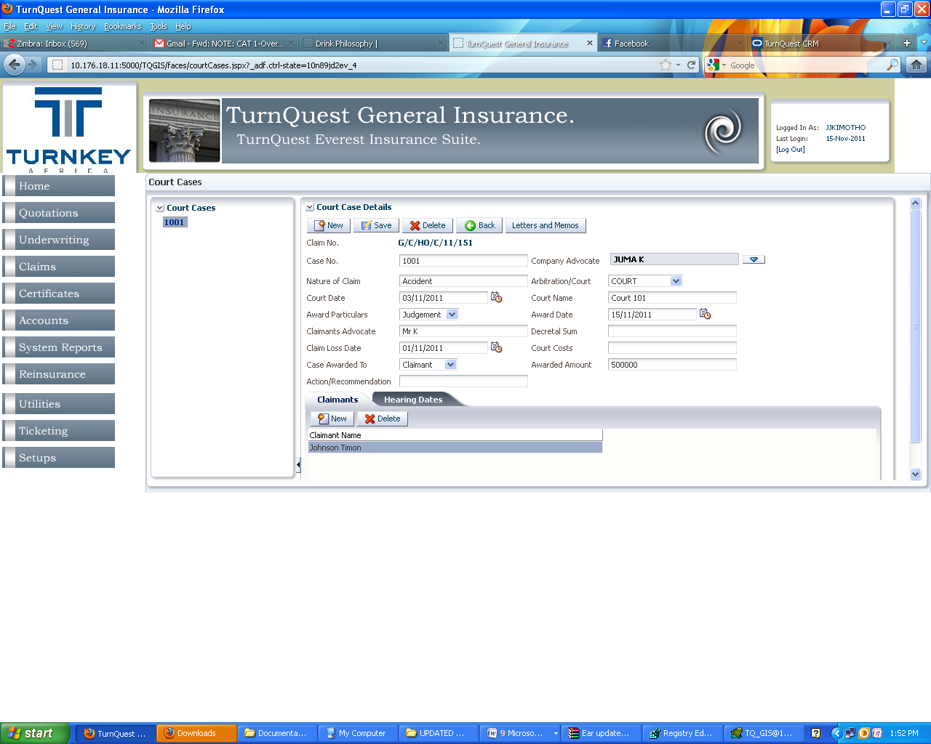

The Claim No. is automatically picked from the claim being accessed, enter the Court case details and save.

Attach the claimants and enter the hearing dates.

To complete the loss opening Transaction click on View transaction Link as shown below

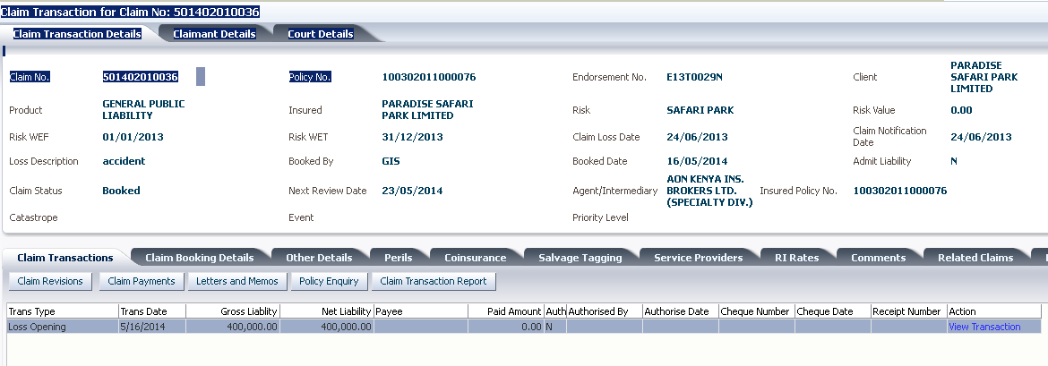

The screen below appears Follow Below process flow to complete the transaction

#### ***Loss Opening Process flow***

*Loss opening data entry >> Authorize Claim exceptions >> Authorization levels>>Authorize Claim>>Dispatch documents>>Ticket Closed.*

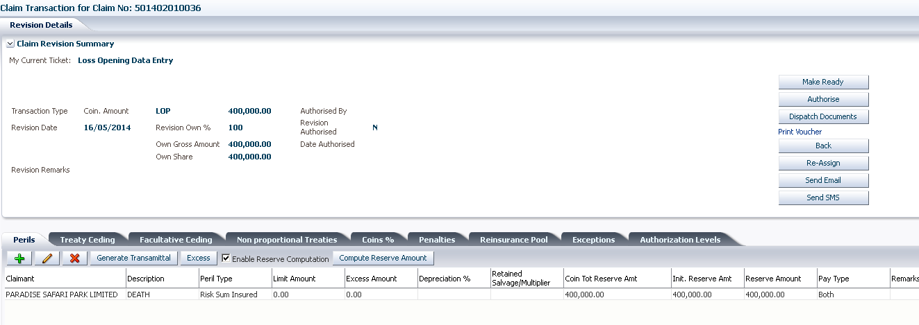

Click on Print Voucher to Print ***Loss Opening Voucher*** as shown above

**Note:** For any other transaction to be started on a claim the Loss opening transaction needs to be completed (Ticket Closed) /Authorized

# **Claims Revision**

This transaction enables user to revise the peril outstanding amount upwards or downwards

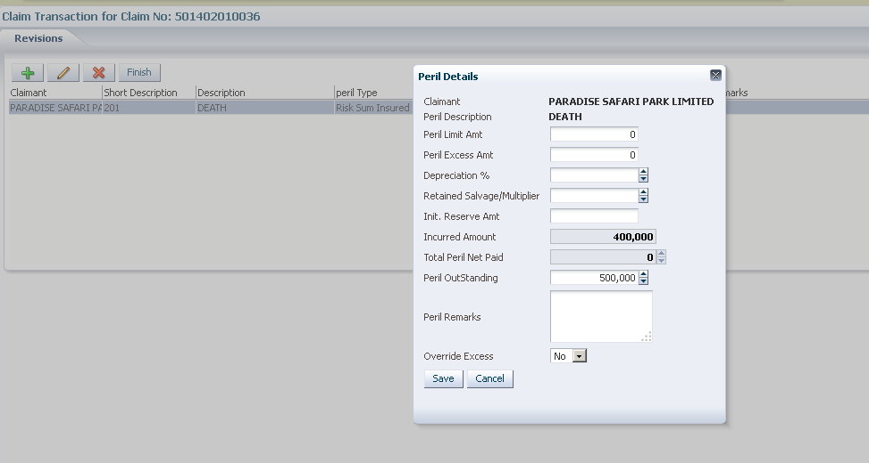

From example above:

Depreciation %: Rate of depreciation on the Sum Insured

Retained salvage /Multiplier: This is the amount worth of the salvage being retained

Initial reserve amount: Underwriter initial reserve

Incurred Amount: Total amount incurred on the claim at any one time

Perils outstanding: Current outstanding reserve on the peril

Peril Remarks: Remark on the peril

Click Save and Finish, below screen appears showing the revision transaction.

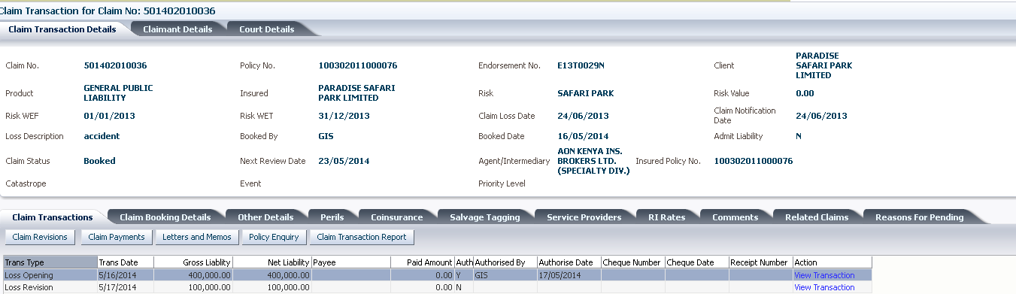

*Current Ticket:* ***Claim Revision Data Entry***

Select the **Loss Revision** transaction and Click view transaction, make ready and authorize transaction.

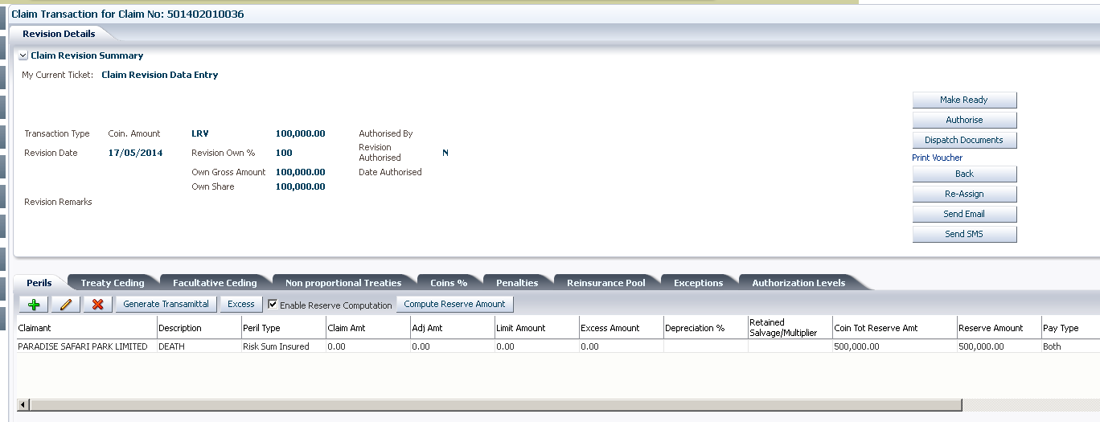

Click on Print voucher ***on the Claim revision transaction to view Claim Revision voucher.***

# **Claim Fee payment.**

## ***Appointing of service Providers***

Select the service Providers tab

**Note:** User has to have Claims Service Provider Access and Authorize Role to appoint service providers

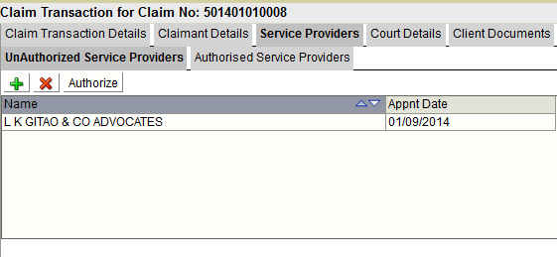

Click add to Add Service providers

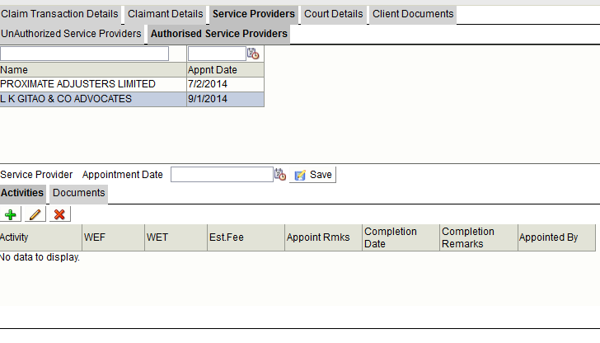

Select Service provider and Click authorize, All authorized service providers will be populated in the Authorized service providers view

Select the authorized service provider and enter the appointment dates and Click save

Click add to add the service provider activities

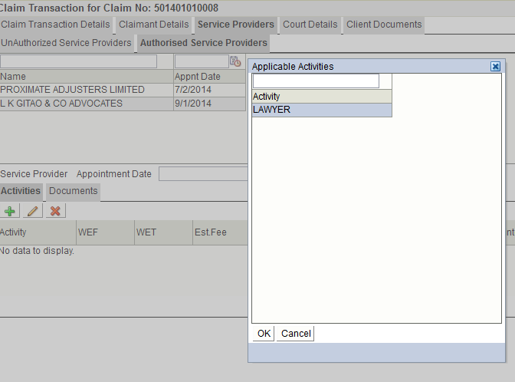

Select the Activity from the list of values as shown above screen is displayed enter the with effect from and With effect to dates, enter the Estimate Fee, the Appointment remarks, the actual date done and the completion remarks from the adjustor and click save. These fields are editable

The system creates a revision transaction as shown below.

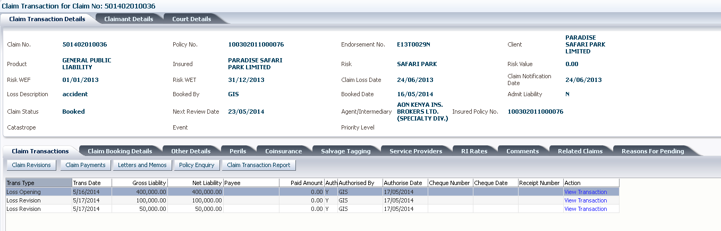

Access the Claims transaction tab to begin a Claim fee payment transaction as shown above *(click on the arrows << “next to the peril tab” for the drop down)*

Click Claim Payment button on the claims transaction screen as shown below.

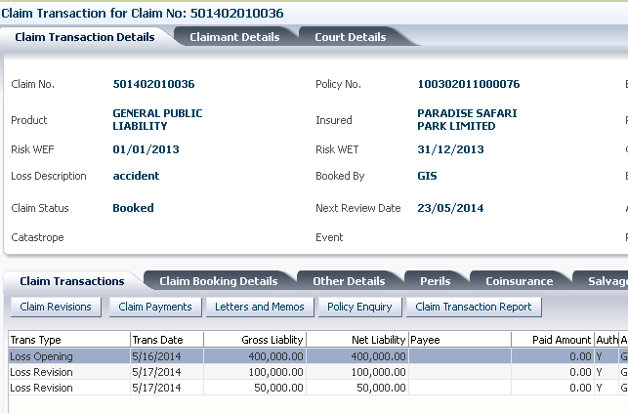

From this screen two transaction types can be started

* Claim Fee Payment
* Claim Payment

## ***Claim Fee Payment Process***

Select the transaction type as Claim fee payment from the drop down as shown below

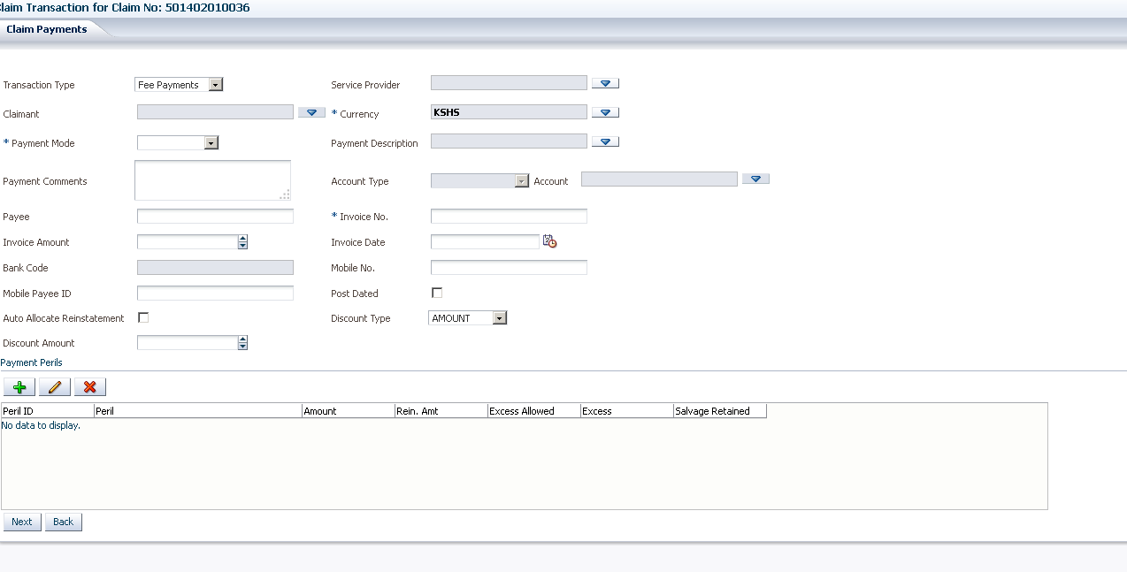

Select Service Provider, Only Service Providers that have been authorized will be listed from the Lov. The service provider selected is automatically selected as the payee see below figure.

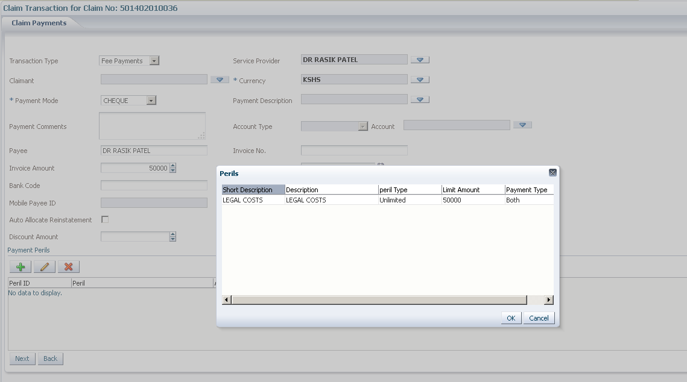

Enter the Payment Amount; select the Payment Modes (setups are done in TurnQuest CRM)

Enter the invoice amount, invoice No and the invoice date from the service provider

Select Claimant Peril as shown above. Click save peril ad the screen below pops up.

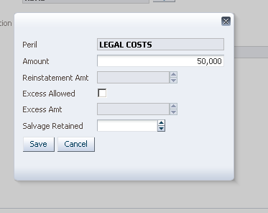

Click on save to continue to below screen that shows the summary of the payment. On this screen one can edit or delete the payment.

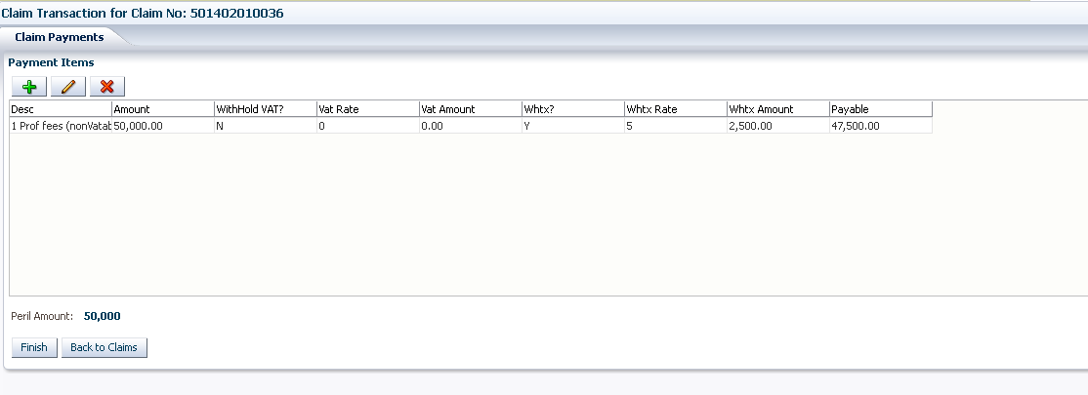

Lick on finish button as shown above, this will take you to the Claim Transaction/ Claim landing screen

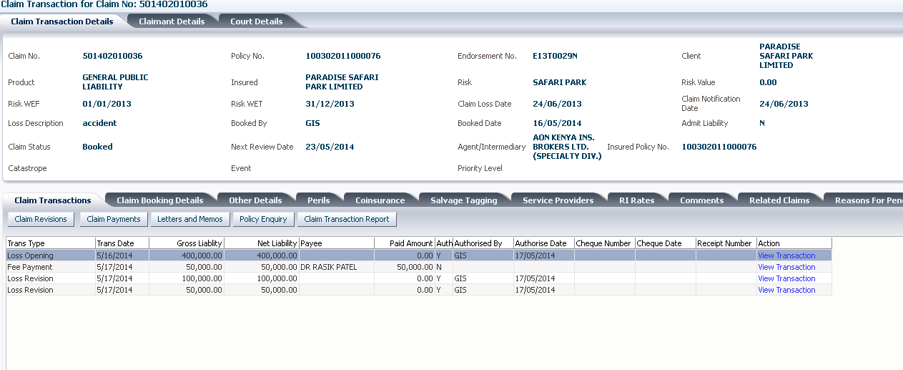

*Current Ticket :* ***Claim Fee Payment Data Entry***

Click view transaction to authorize the transaction as shown in the screen below

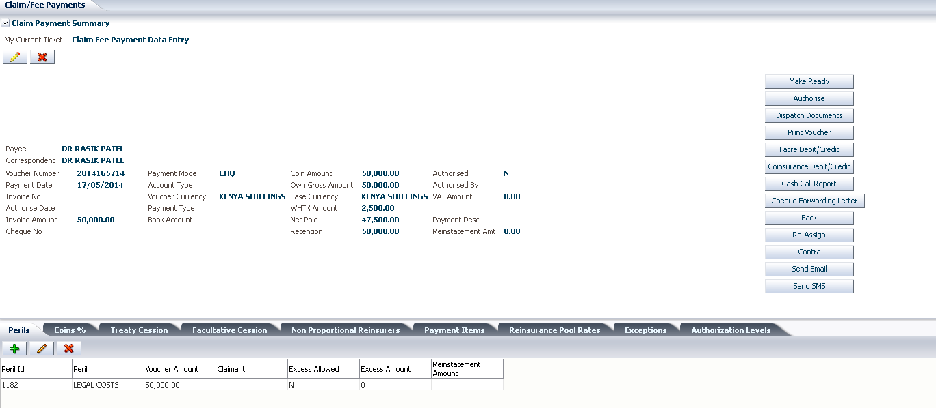

At this level you can be able to edit/ delete the fee payment details by clicking the edit button, this will redirect to the claim payment details screen where the details on the invoice can be updated and saved as shown below

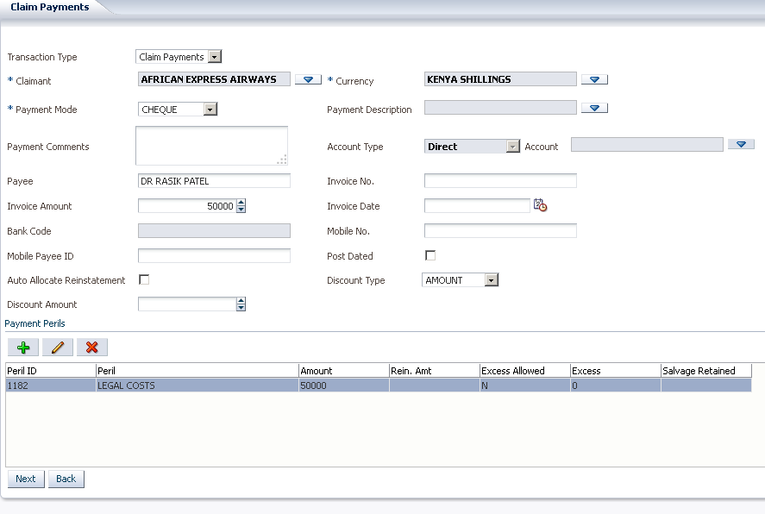

**Note:** Delete is allowed on all transactions except Loss Opening and Loss revision transactions

Proceed and authorize the payment and cheque requisition will be posted to FMS system for Printing. Once the cheque is printed the payment in claims will be marked as Authorized.

# **Claims Payment**

## ***Claimant Details Tab***

Go to the claimant details as shown on below screen and click on view discharge vouchers.

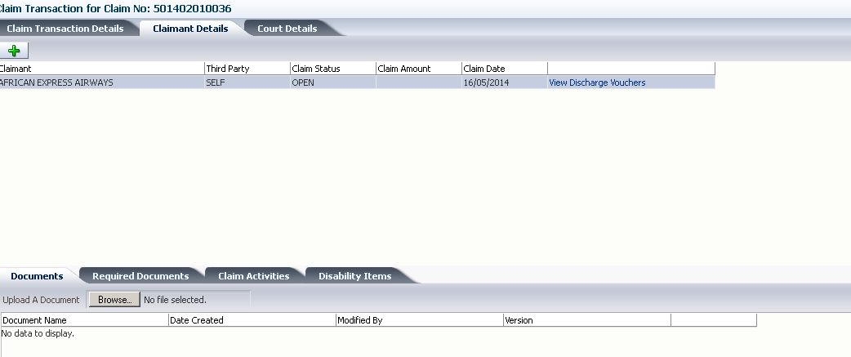

Click adds to get below pop up. Add the transaction type and select the peril. Click save .

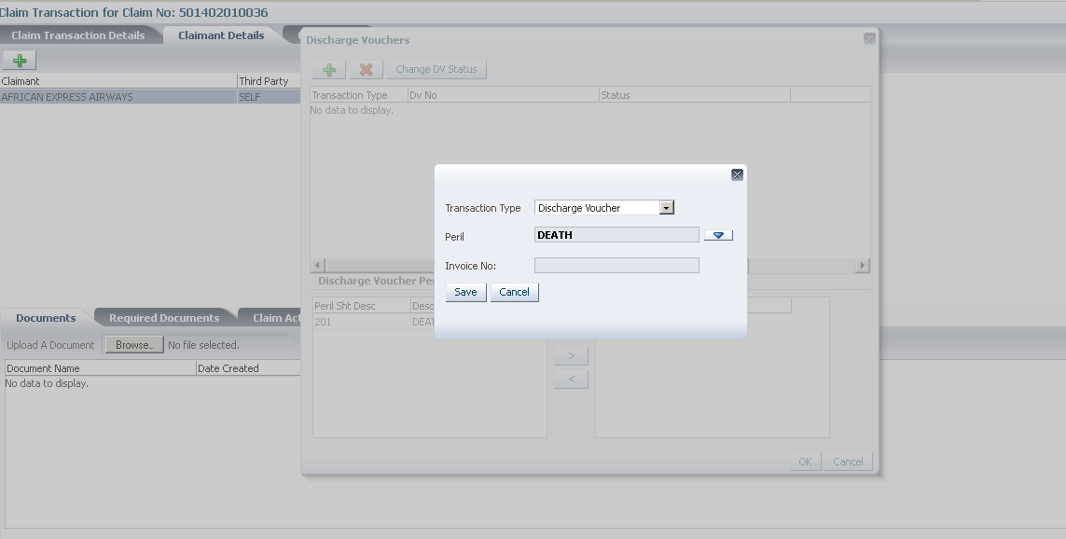

Click on save to get to below screen

## ***Discharge Voucher (DV)***

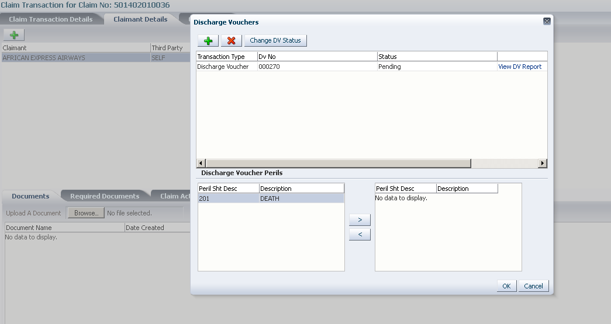

The Discharge voucher appears with status pending as shown above.Select the DV and Click on change DV status to indicate if the DV is Accepted, dispatched or Rejected, as shown below.

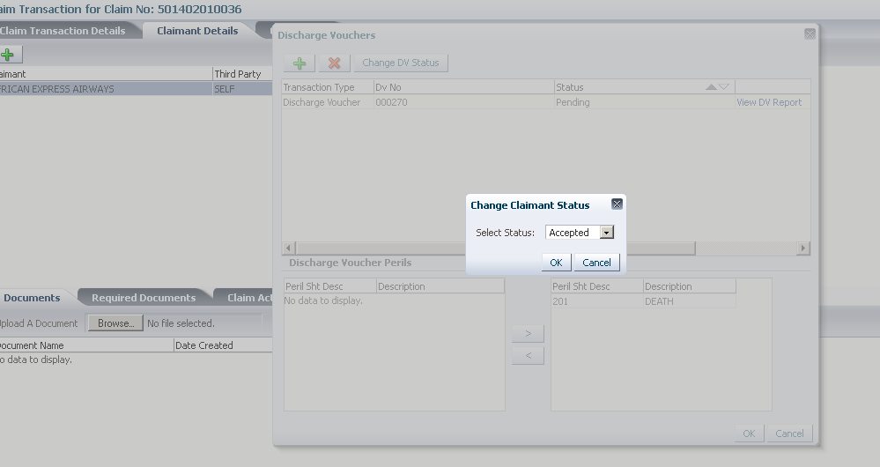

Click Ok to change the DV status as shown above and ok to close the dialog box as shown below.

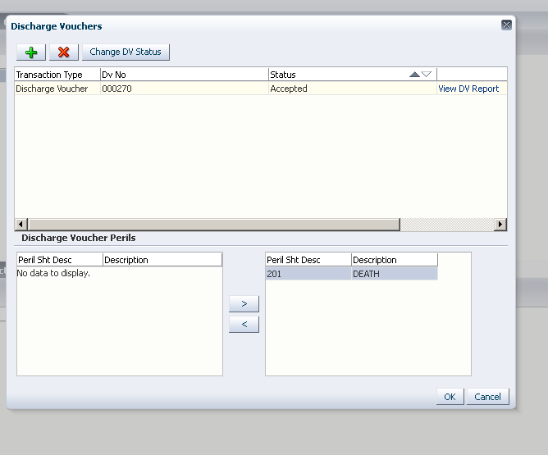

## ***Claim Payment Process***

To start the payment, select the transaction type as Claim Payment from the drop down as shown below

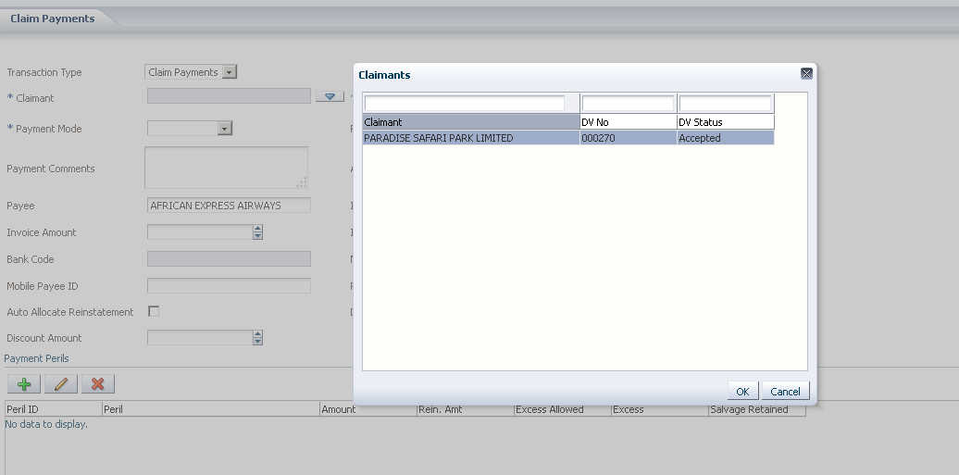

Select the claimant as shown above

Select payment mode; enter the invoice amount and the invoice date.

Select the peril as shown below.

Select the peril and click ok, below popup appears

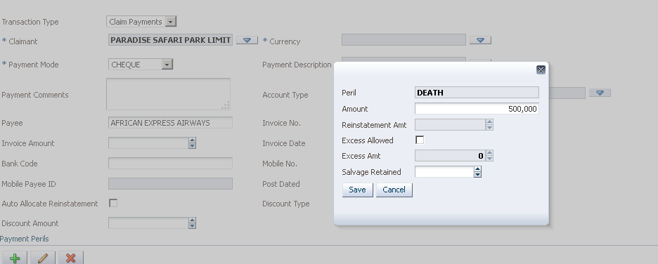

This shows the peril and the peril amount, excess allowed for those classes where excess is applicable and if client is retaining salvage the figure is entered on the field below where applicable.

Click on save to move to the next screen as shown below



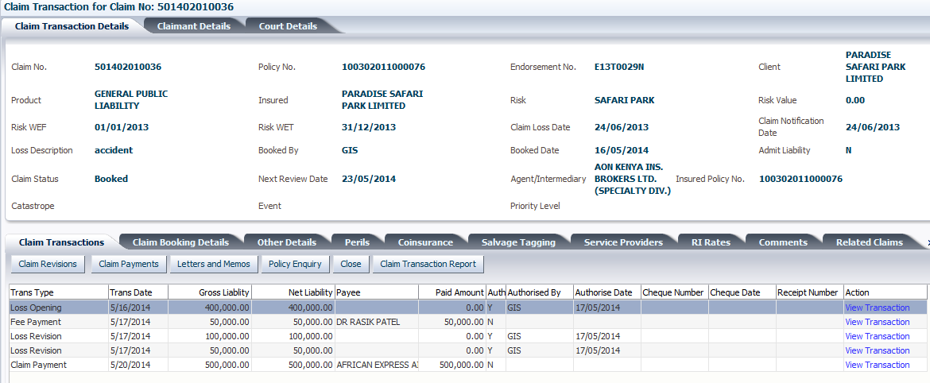

*Current Ticket :* ***Claim Payment Data Entry***

Click on view transaction.

At this level you can be able to edit/ delete the payment details by clicking the edit button, this will redirect to the claim payment details screen where the claim payment details can be updated and saved as shown below

To enter the Voucher amount Select peril and update the voucher Amount

Click **Make ready** one the details captured are verified

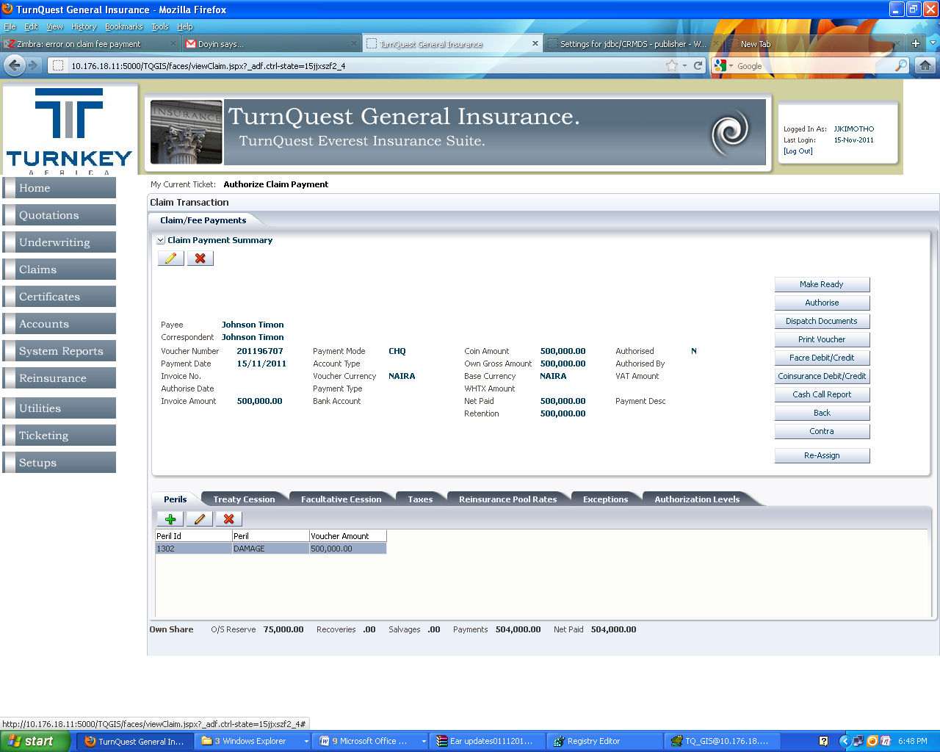

At this point you one can make ready and authorize the payment. A cheque requisition is posted to FMS system for printing.

**Claim Payment Process Flow**

*Claim Payment Data Entry >> Authorize Claim exceptions >> Authorization levels>>Authorize Claim Payment>>Dispatch Claim Payment documents>>Ticket Closed*

To print the ***Claim Payment Voucher*** Click on Print voucher

# **Claims Salvages**

This is a transaction type can be captured in two ways:

* Salvage retained by Insurance Company
* Salvage retained by Claimant

Once a claim is booked, an acknowledgement letter is done to the claimant acknowledging receipt of the claim notification and also asking for the claim substantiating documents. This letters are done using the letters and memo screen which is accessed by clicking the letters and memos button in.

## ***Salvage retained by Claimant***

On the claim booking details tab click on edit and select **Type of loss**: TOTAL LOSS

Salvage Retained select **Yes** and save the claim details

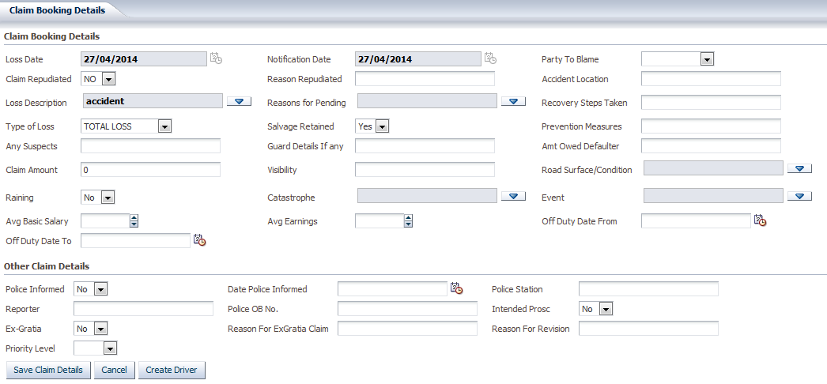

Select transaction and click view transaction, select peril and click edit

## ***Salvage retained by Insurance Company***

On the claims booking details tab click on Edit

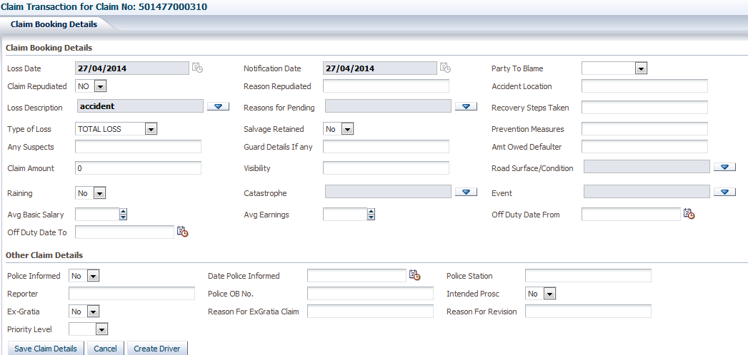

Select **Type of loss** as TOTAL LOSS and the Salvage Retained set to NO (This means that the salvage will be sold by the Insurance Company)

## ***Salvage Tagging Tab***

Click on the Salvage Tagging Tab as shown below and add in the details.

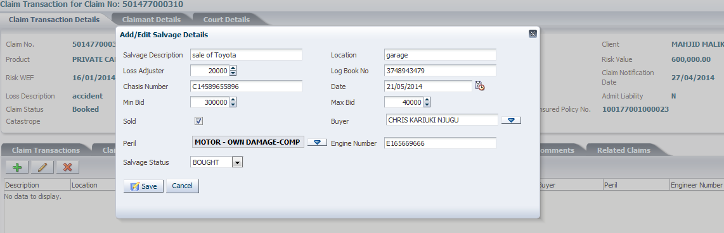

Note : A salvage receipt has to be captured in The FMS system , then recovery transaction is created in GIS automatically.

### ***FMS salvage receipting***

Log into TurnQuest FMS

**Cash Book >>CB- Receipts >> Capture** as shown below

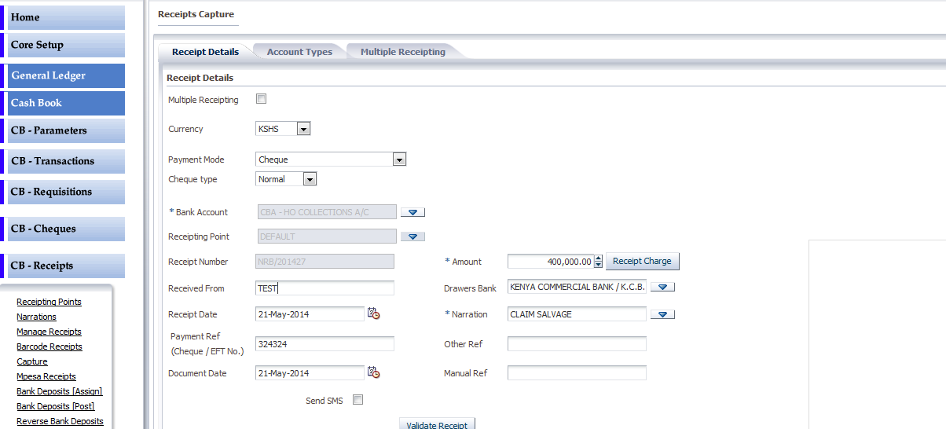

Select the Currency, Select Bank Account and Payment Mode, Enter the Receipt amount and the Received From details, Select Receipt date and select/ enter the narration of the Receipt. Click on Validate Receipt button

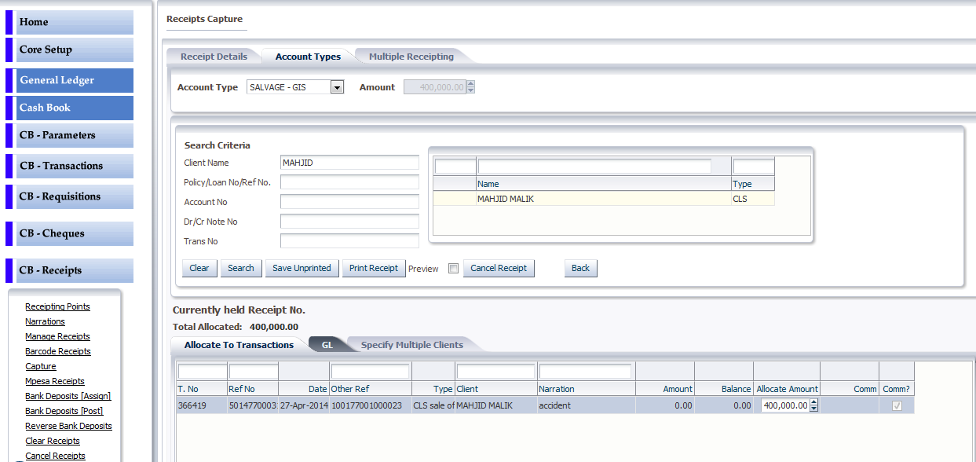

Select Account Type as SALVAGE- GIS, Amount is picked from what was entered in the Receipts details screen.

Search for the Client by Client name/ Policy No. or Ref No. or Debit No number

Select the Claim transaction (denoted by CLM) this will auto populate Auto Allocate to Transactions tab with all claims attached to the client (this is based on the search criteria used from the above example Client name was used). The amount is also shows on the Allocate amount field.

Click on Print receipt , system displays the recipt Number generated as shown on below screen.

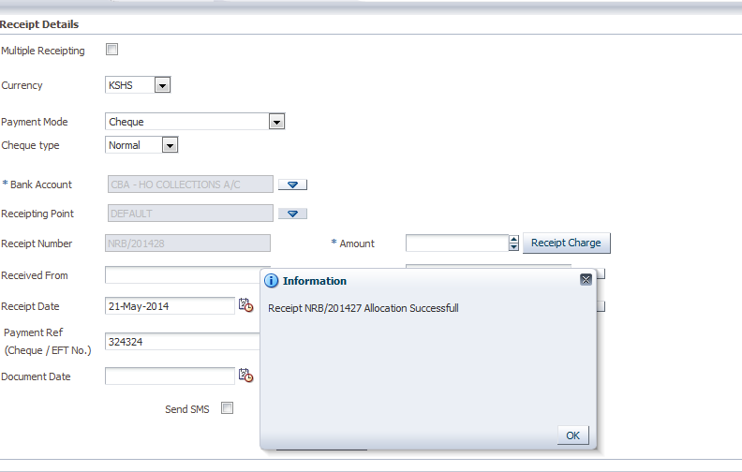

After receipting a Salvage transaction is automatically created in GIS as shown on below claim. Notice the transaction is authorized and shows the receipt number.

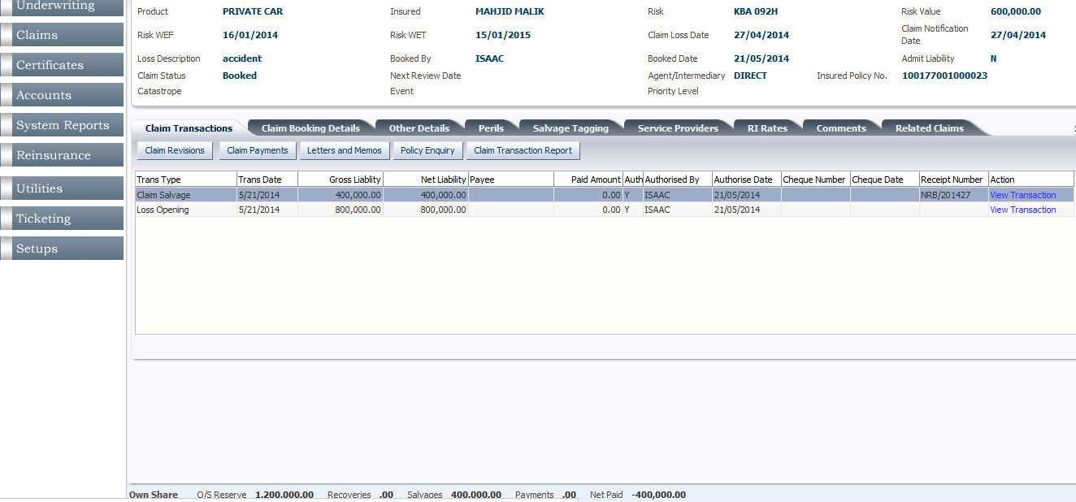

# **Claim Excess.**

Excess amount is computed as per the setup on subclasses. This is reflected on the Peril details or if not set up one can enter the peril amount on revision. See careen below.

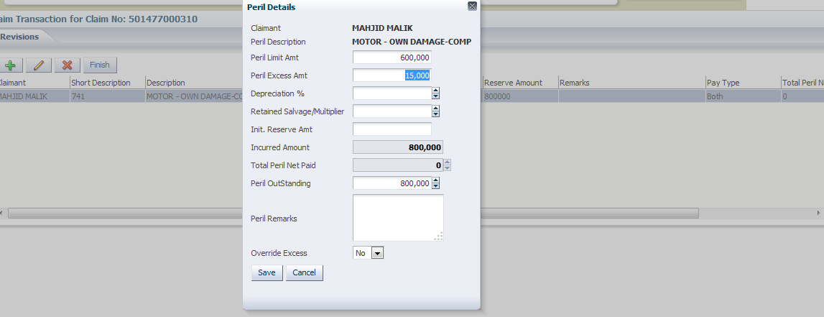

A receipt has to be captured for this transaction

## ***FMS Excess receipting***

**Cash Book >>CB- Receipts >> Capture** as shown below

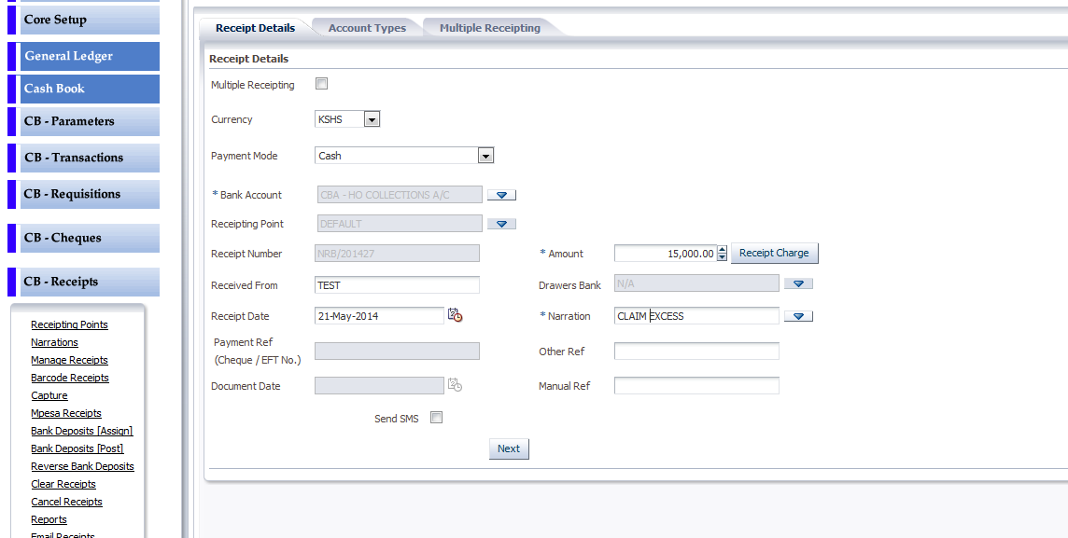

TurnQuest FMS to capture a receipt. For excess Select Account Type as EXCESS –GIS as shown on below screen.

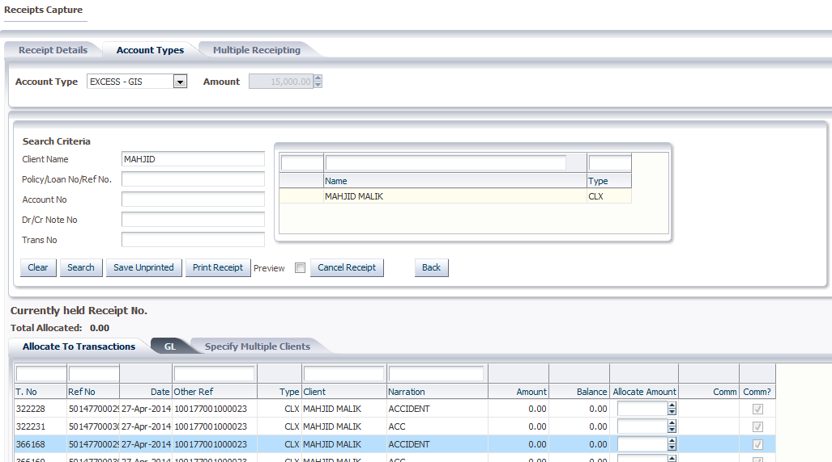

Allocate on the claim and print the receipt as shown below.

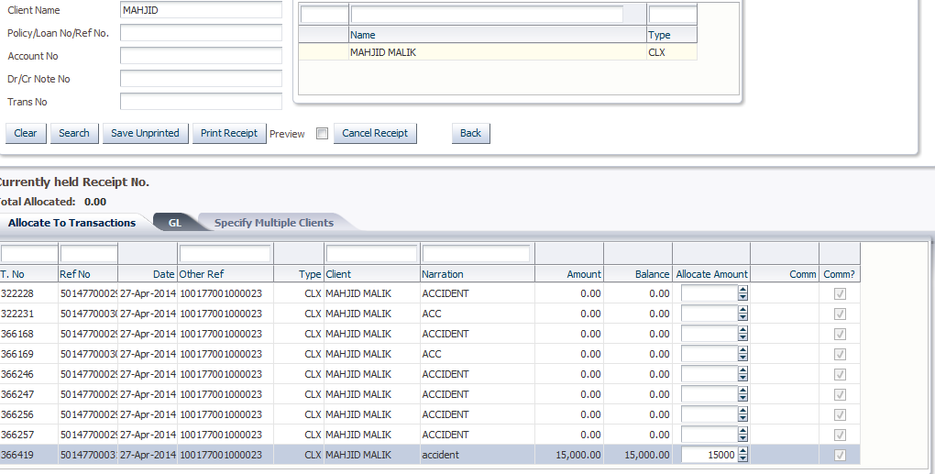

Once a receipt is done a Recovery transaction is created automatically in GIS.

# **Claims Closing**

A claim can be closed when the outstanding reserve becomes zero

When authorizing the transaction the below dialogue box is displayed

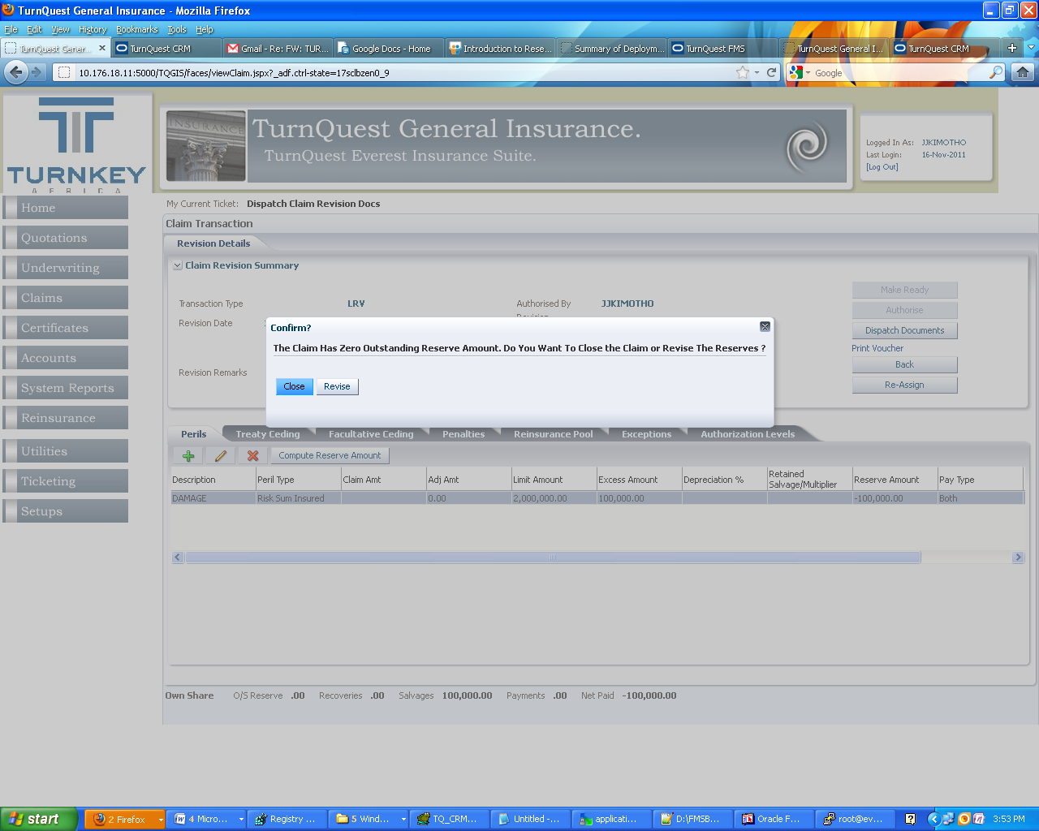

There are two options available, either to Close the claim (click close button) or Revise the reserve (Click revise button this will redirect to the claims revision screen) and close claim closes the claim either as settled after payments are done , or one can close the claim is rejected.

# **Claims Reopening**

A claim to be reopened will be accessed through claims enquiry

**Claims Module>> Claims Enquiry**

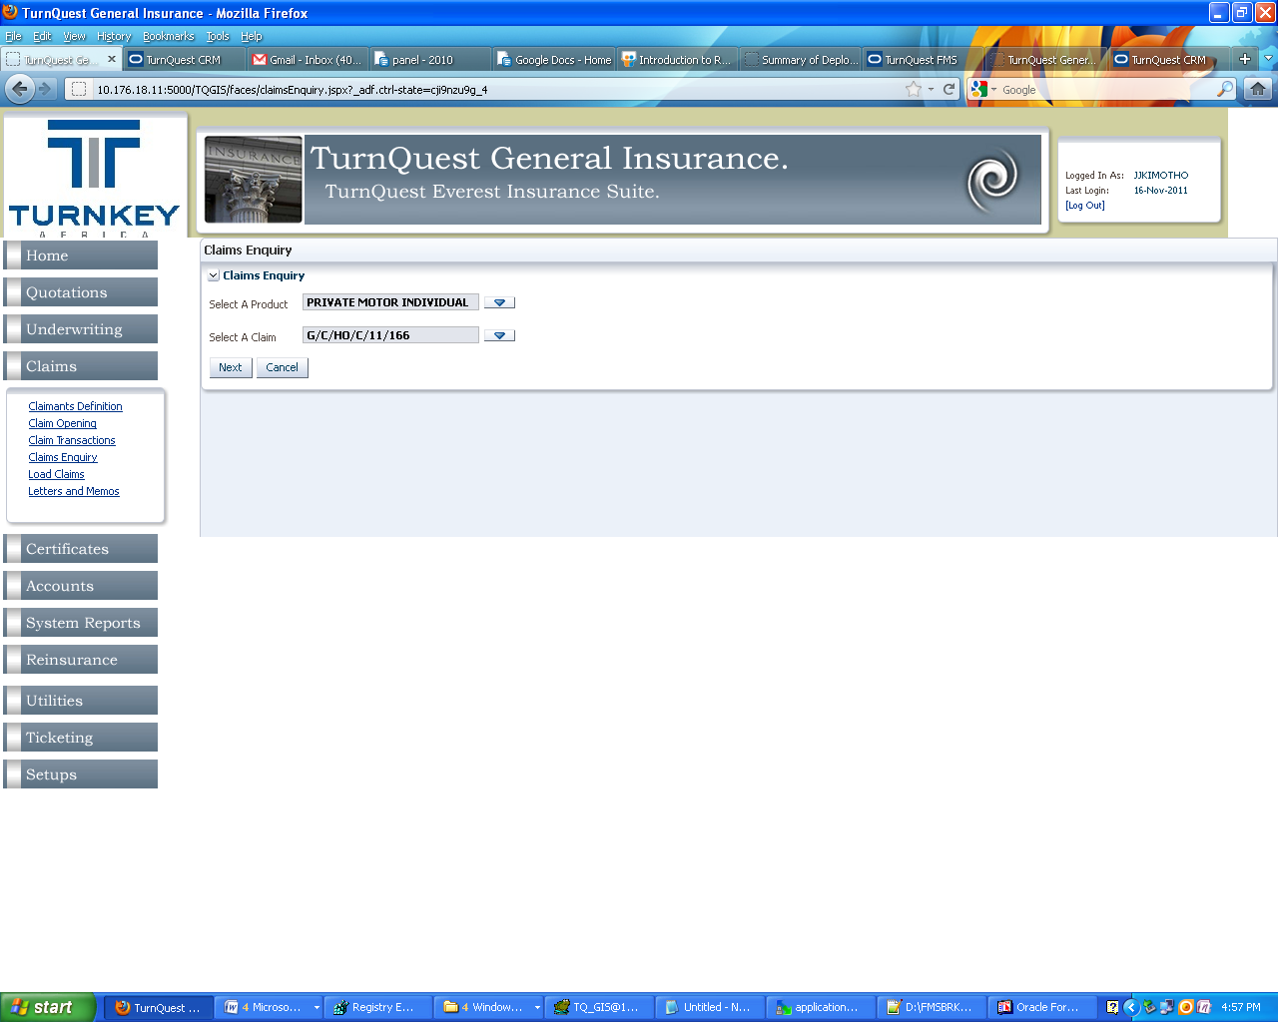

Select product and claim to be reopened. An example is shown below. Claim status is **Closed**

**Note:** The button Reopen is enabled.

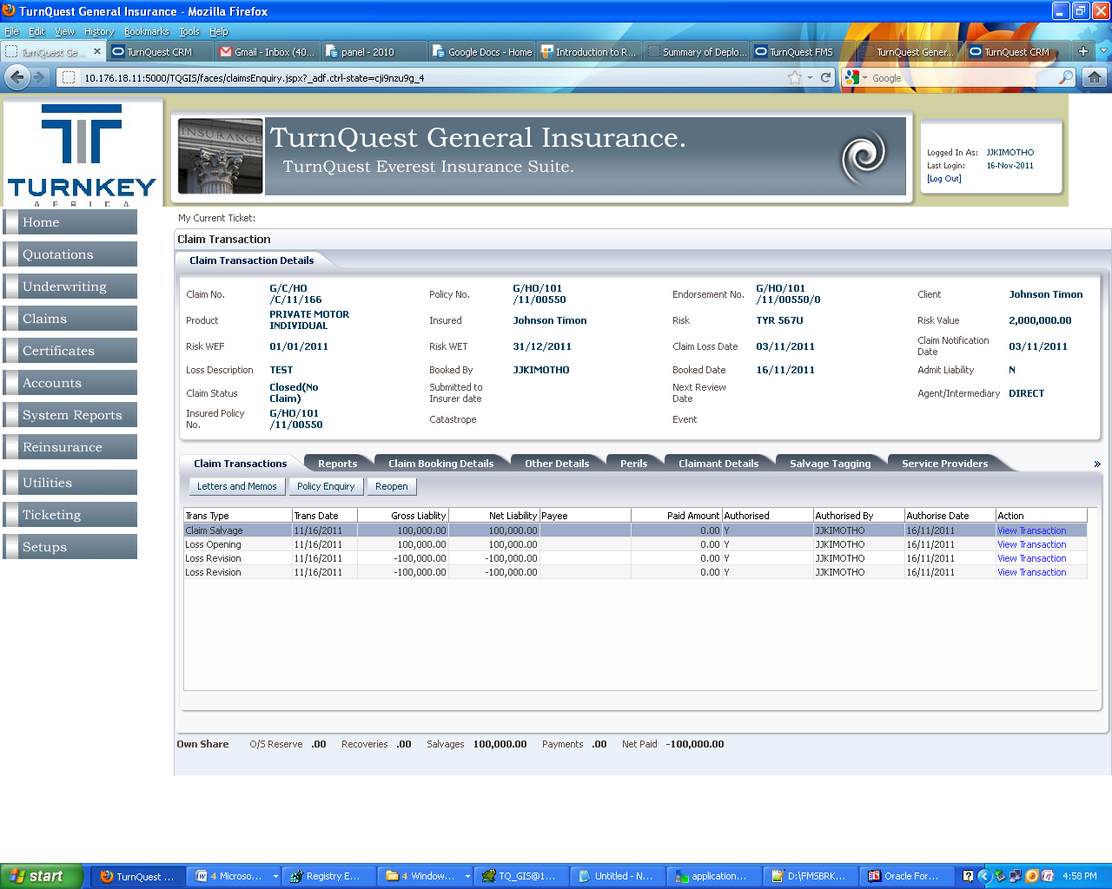

Click on Reopen, this directs you to the Claims revision transaction screen.

As shown below. Edit the peril outstanding amount and click save

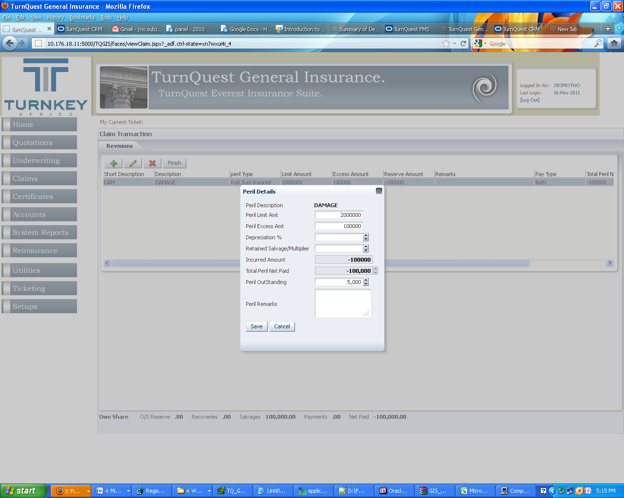

Click Finish. This in turn creates a revision transaction and the claim status becomes **Re-opened**

As shown below

*Current Ticket****: Claims Revision Data Entry***

# **Claims Contra**

There are several transactions that can be contrad / reversed in TurnQuest GIS system. These are

* Claims Payment
* Claims Fee payment
* Claims Salvage
* Claims Recovery

**Note:** Loss Opening (Claim Opening) and Claim Revision (Loss Revision) transactions cannot be Conrad. To Reverse a Loss opening Transaction a revision is initiated and revises the outstanding amount to zero and close the claim as **No Claim**

From the Fee Payment transaction below Click View transaction

**Click On Contra**

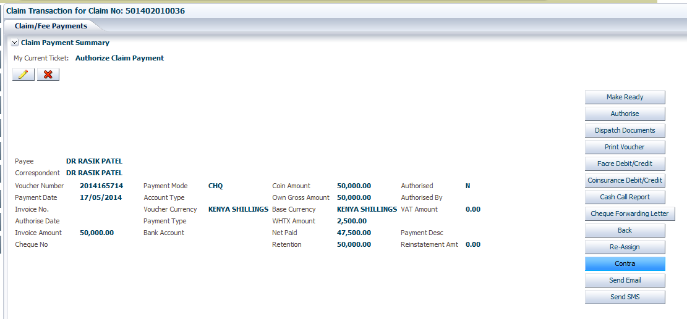

The dialogue box below is displayed click on Ok to reverse the transaction.

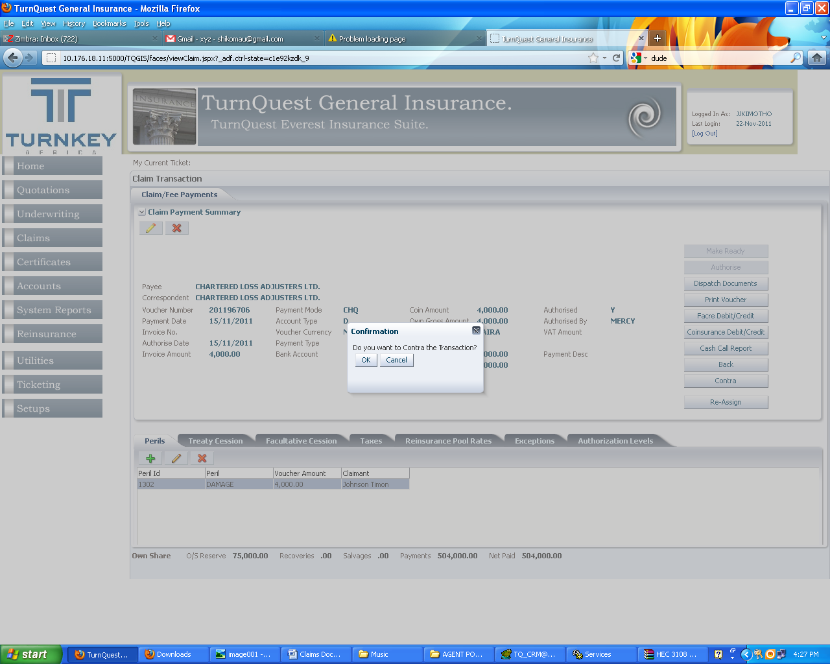

**Note:** The same procedure is used when we contra Claims Payment, Claims Salvage, Claims Recovery

A contra transaction for the claim fee payment is created as shown above. Click View transaction to authorized the transaction.

# **Claim enquiry**

This screen is used to query the status of a certain claim or view the various transactions on a certain claim. This screen is accessed from the Claims Module> enquiry as shown below.

*  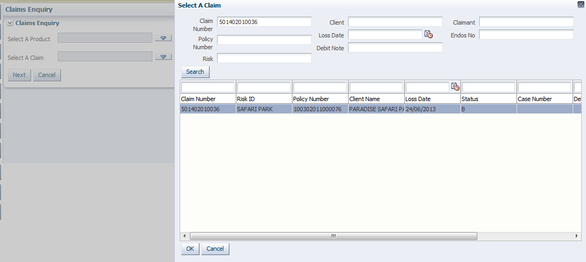
* Select the Claim number and click on Ok to

# **Claims Editing**

A claim transaction is editable if it has not been authorized; it can be accessed for Add/Edit/Delete Claimants, Add/Edit and Authorize Service Providers, Add/Edit/Delete Legal details and Update claim booking details or continuation of a process by a user through his / her assigned tickets by Clicking Process or Select ticket right click and click process the ticket (through home page) or through **Claims Module>> Claims Transactions**

## ***Claims Transactions***

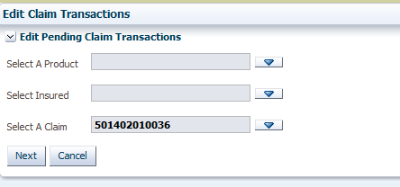

Search for Claim, Select product, Insured and Claim Details and click Next, the Ticket information view is enabled as shown below

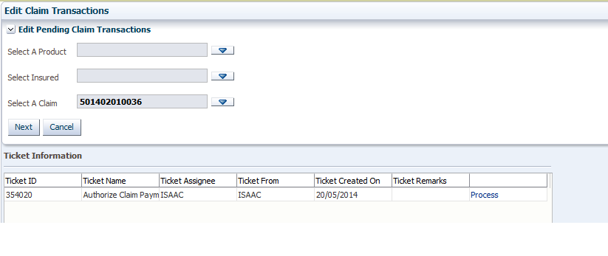

If a claim transaction is assigned to the user logged in the **Process** link on the Ticket information view is enabled

If user trying to access the claim transaction is not assigned the claim transaction they will not be able to proceed.

**Note:** User can only be able to enquire on the claim if task is not assigned to him

Click on the Process link.

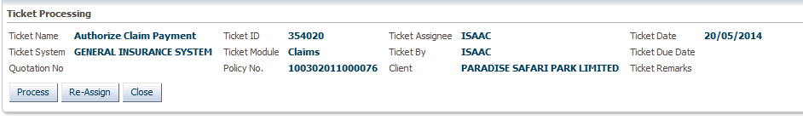

On the ticket processing screen user can proceed by clicking process or assign the claim transaction to a different user. If reassigning; Click on the Re-assign button and select the user to reassign task

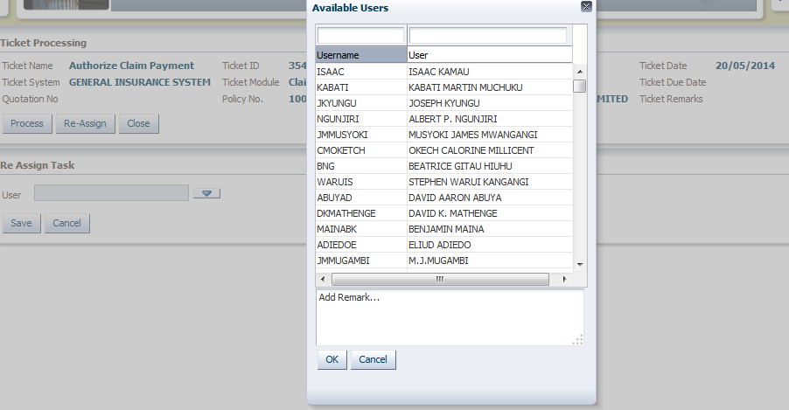

If user has clicked on process ticket they will access the Claim Transaction Screen/ Claim landing Screen

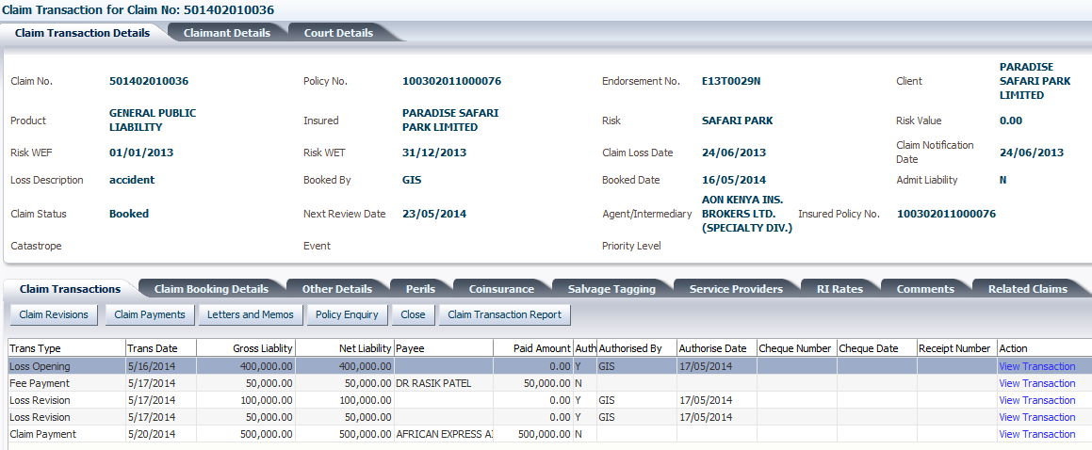

# **Claims Loading**

Claims Module >> Load Claims

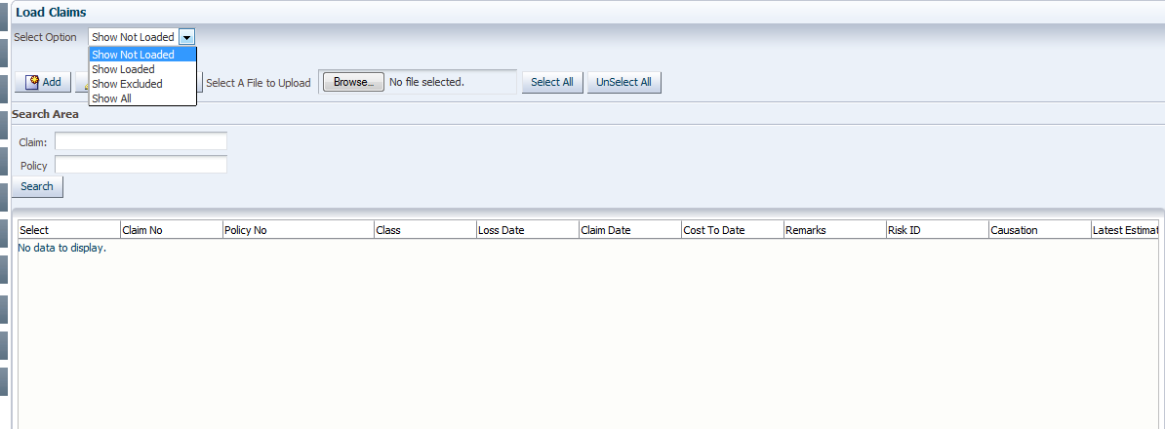

This section is used to load claims it has above options as show on the above screen.

To load a new claim click on add as shown on below screen

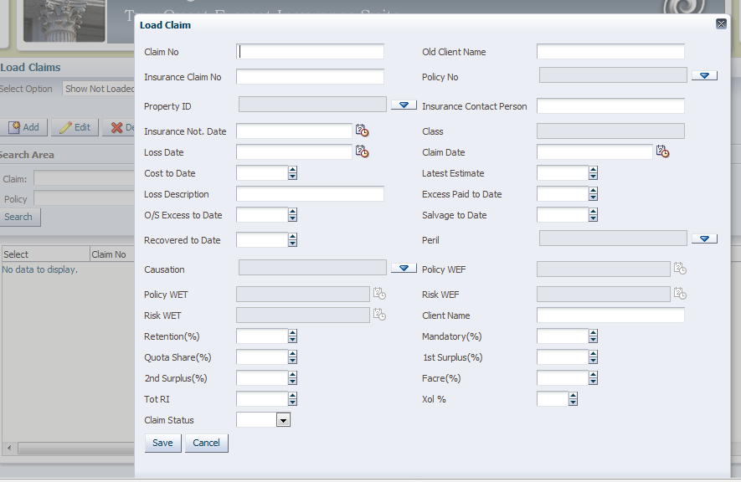

Enter the Claim No, Old Client Name

Select the policy and the specific risk that the claim is being loaded for from the drop down lists

Enter the Notification date, Loss date and the Claim date

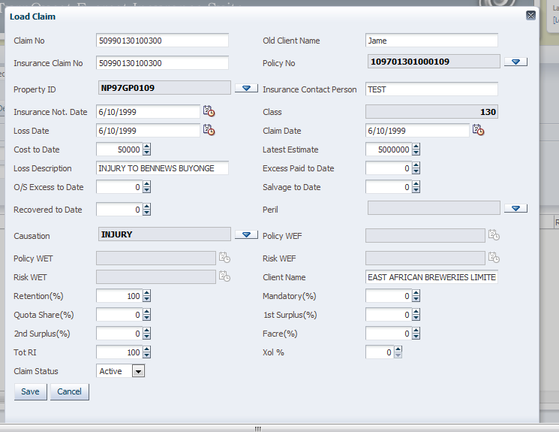

Cost to date: Payments done, this will create a payment transaction

Latest Estimate: Latest Outstanding reserve. Click **Save.**

Select the claim and Click **Load.** A pop up will appear as shown below.

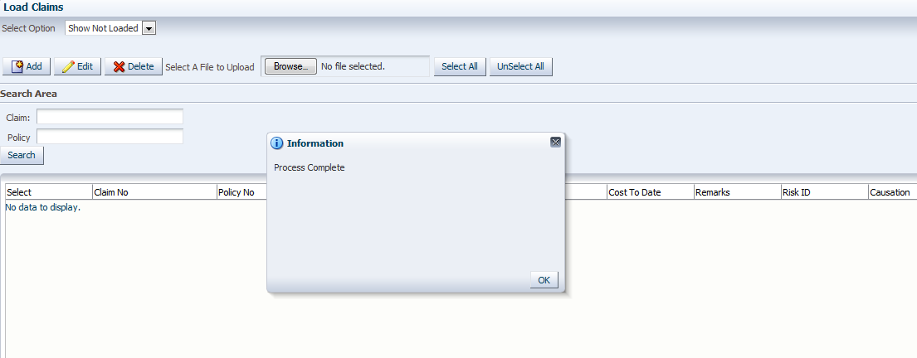

# **Claim Authorization levels**

These are the authorization levels that are set up for each Transaction Type. They are usually activated (if Set up) when a transaction is Made Ready. Both Exceptions and Authorization levels are populated when the Button Make Ready is clicked. Setups are done in TurnQuest CRM for Authorizations

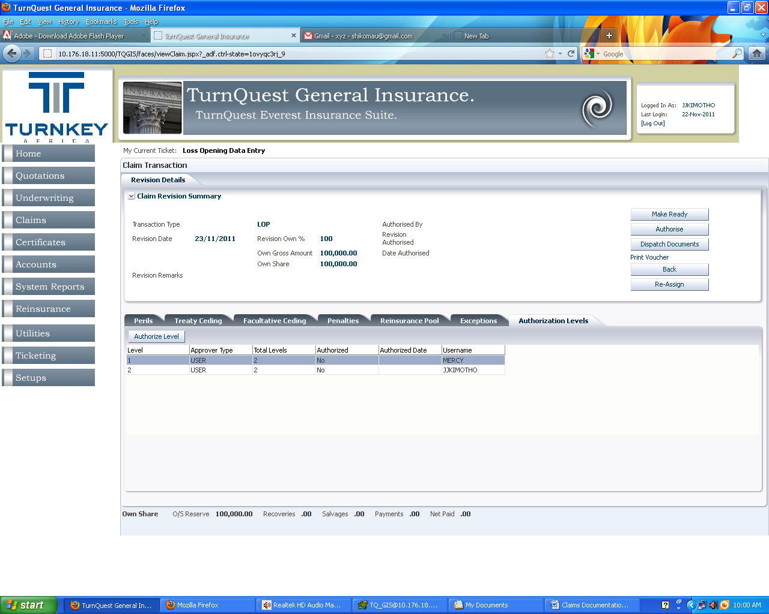

An example (above) that has two authorization levels. The task to authorize is automatically assigned to the first user, who receives a notification via email to authorize. Once authorized the ticket is assigned to the second user if they are different.